2014

“I think he knew everything he needed to know and wanted to know, about the Xmas letter.” – Dick “Darth” Cheney, speaking of W.

Episode 26. The year of Conscious Uncoupling, Ebola, photobombs, ice bucket challenges, adorkable (that’s me), bae, said no one ever, because.

And … the year, in summary. If you want the full story, you are (or should be) on Facebook. Because Ebola.

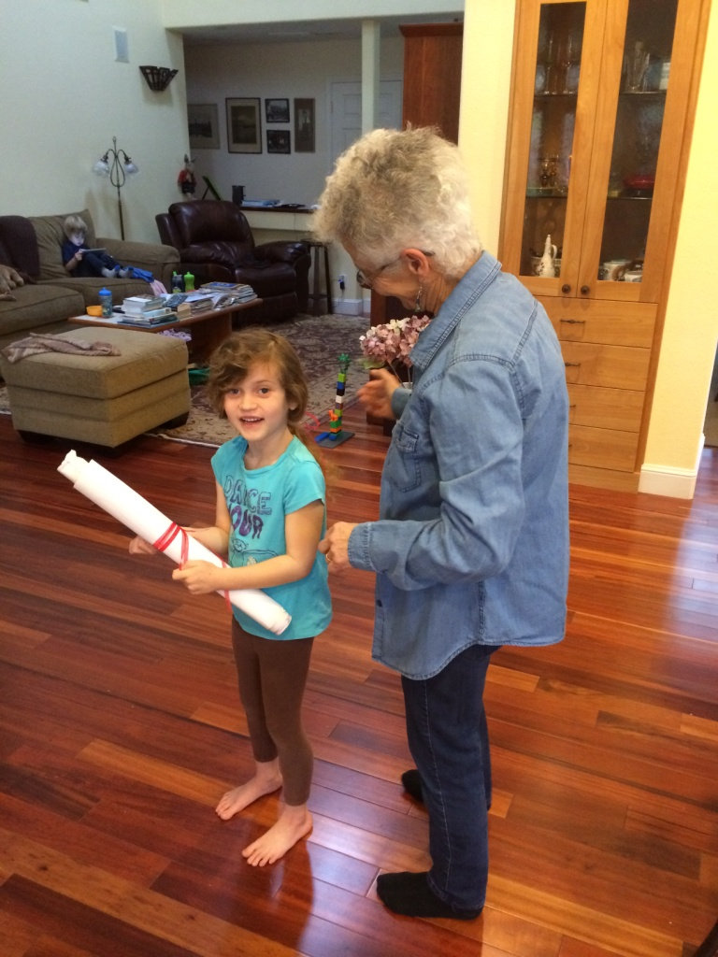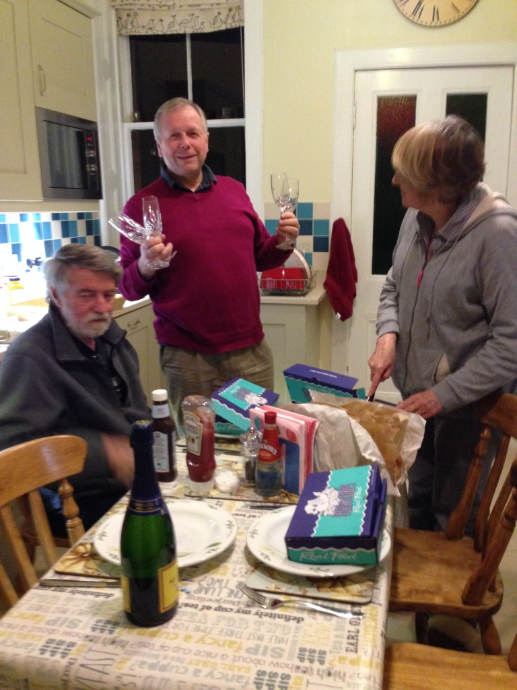

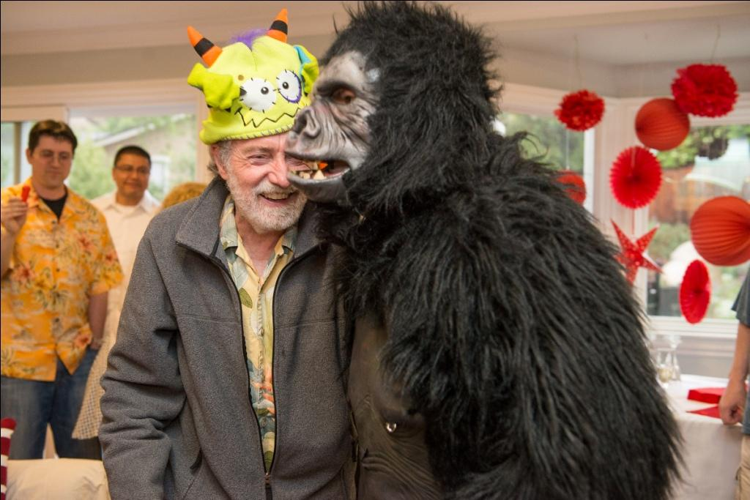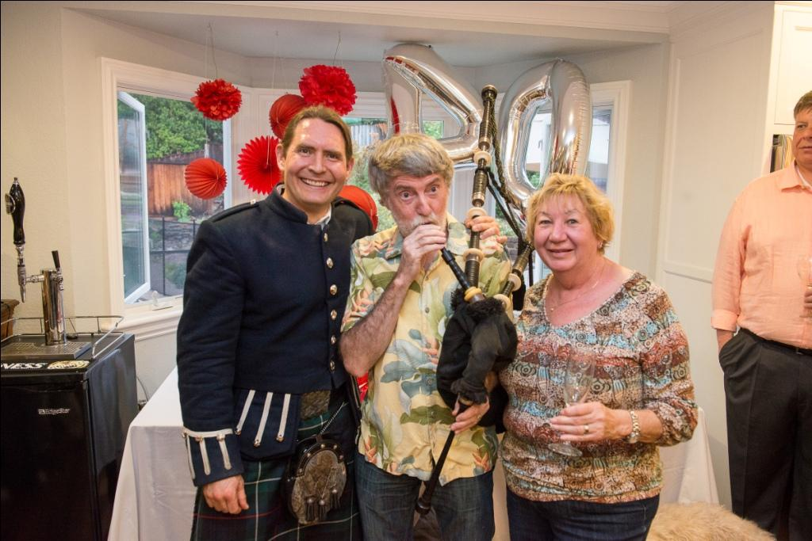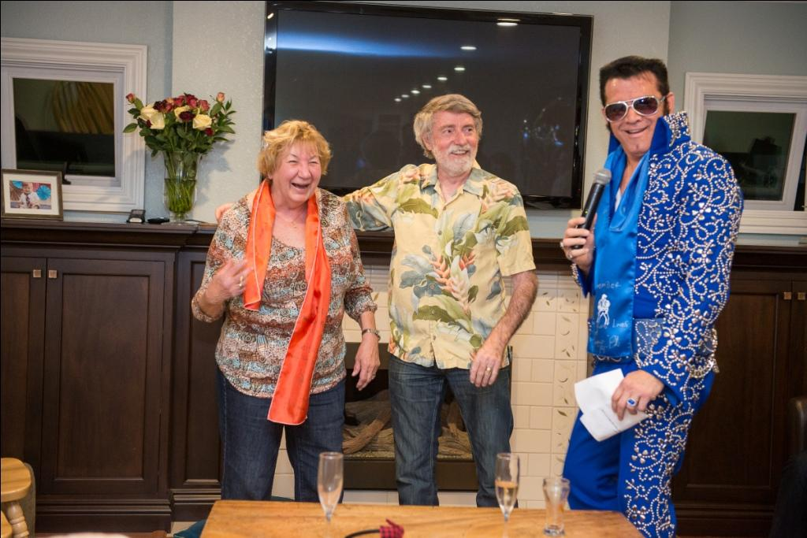

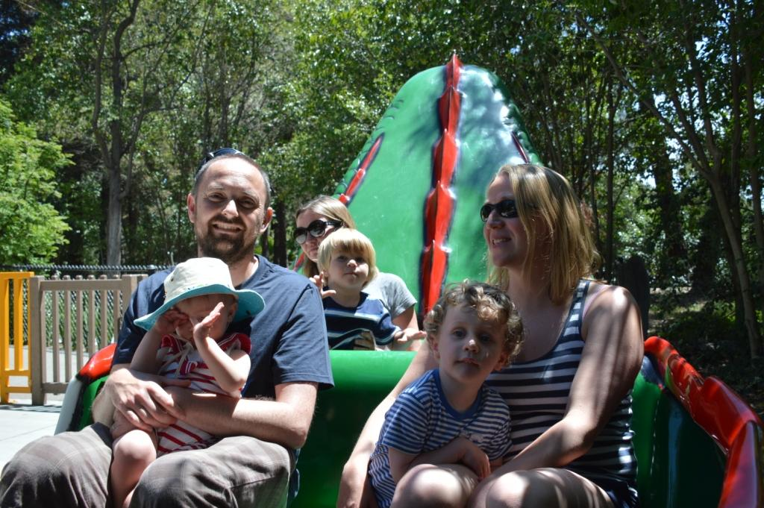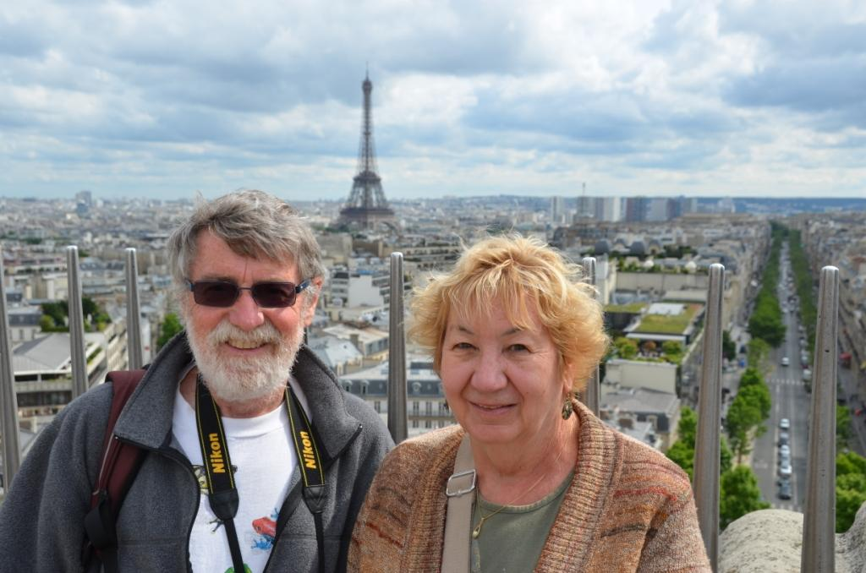
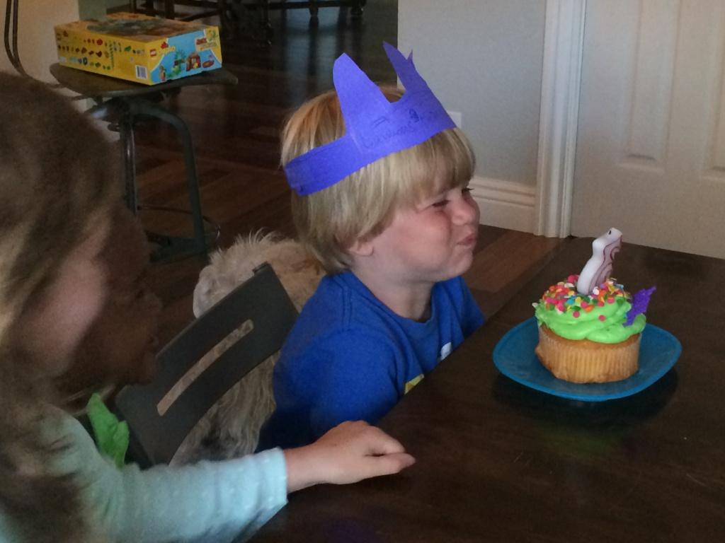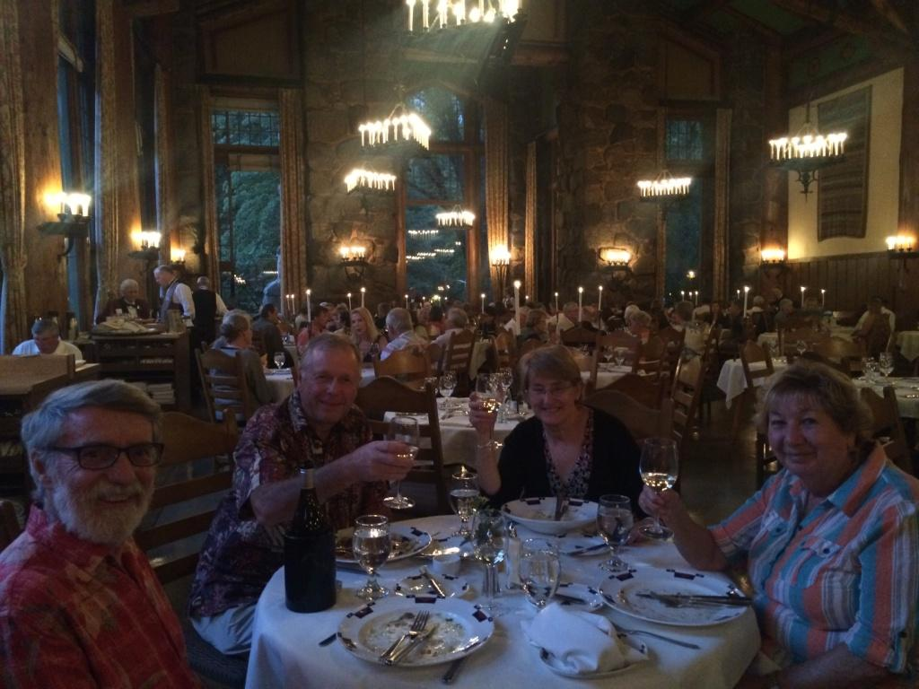

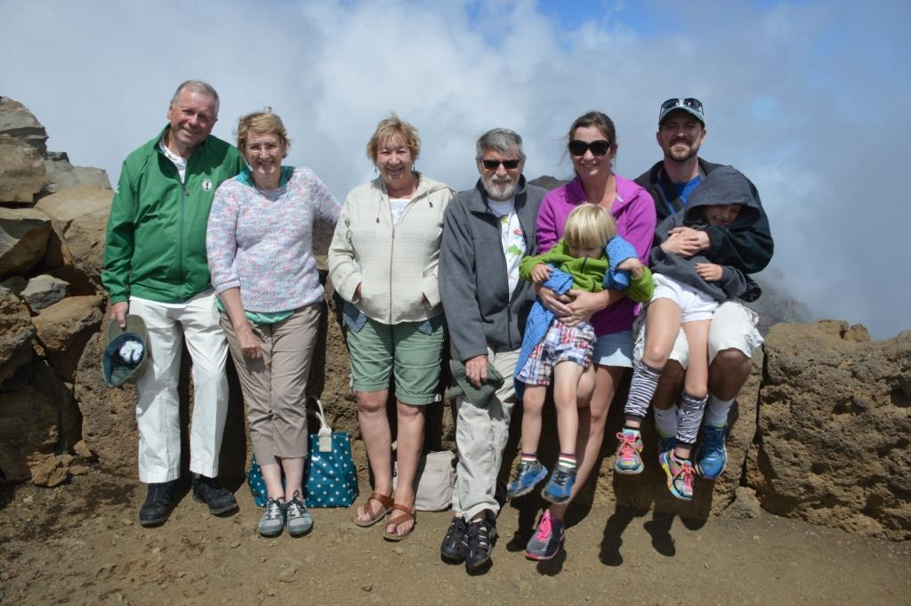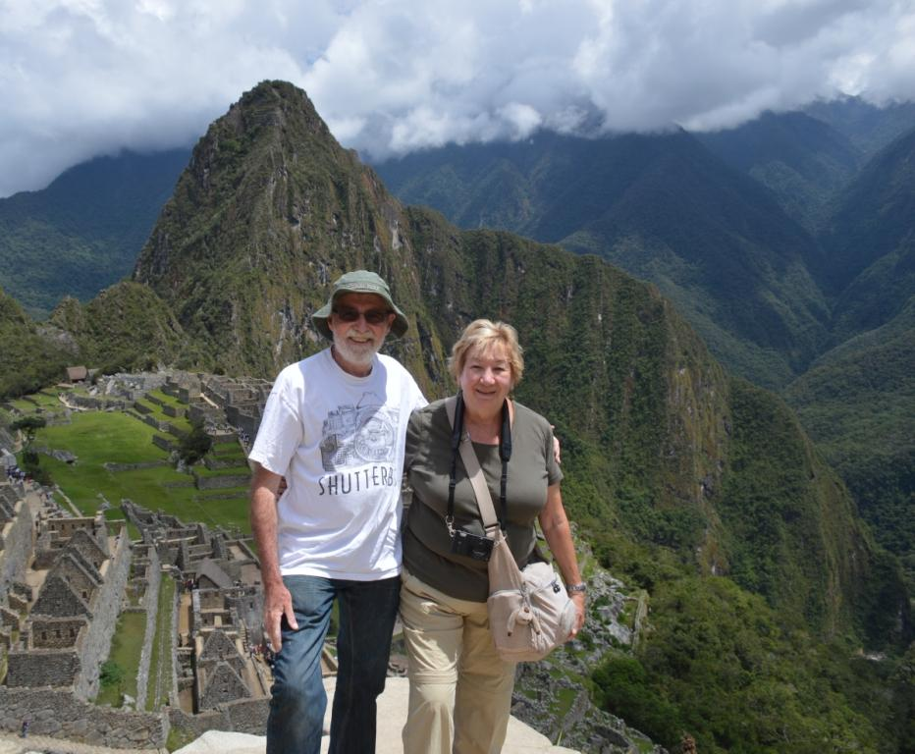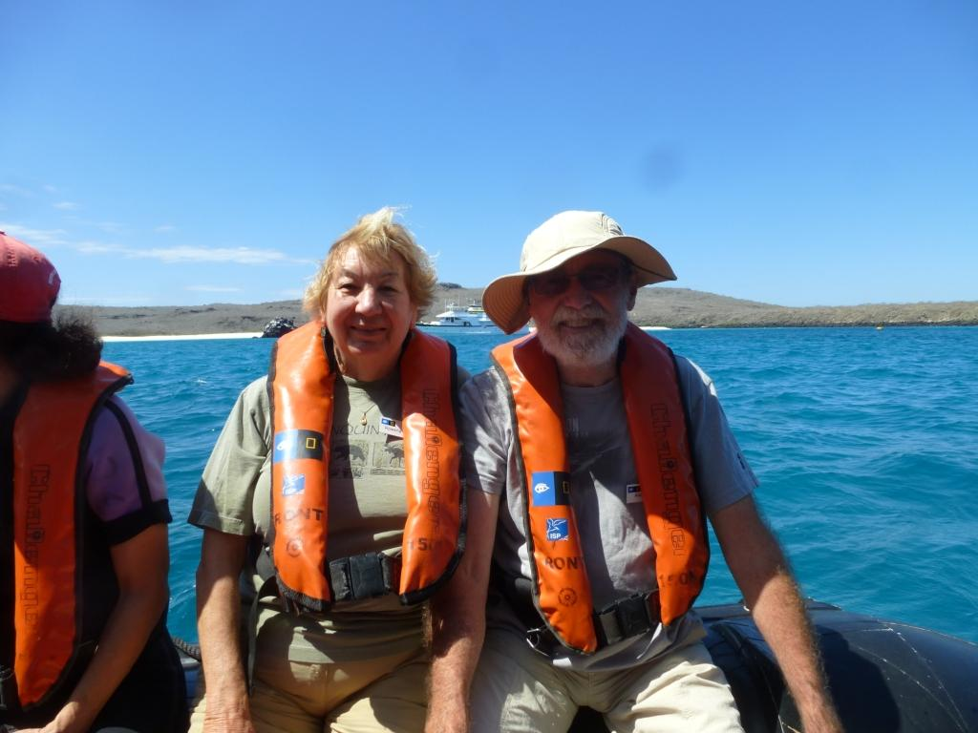

In my never-ending quest for truth on the Internet, this year’s quiz is all about entomology. That’s bugs. In order to see bugs, just use Facebook. Or Yahoo. Or Windows. Or MACOS. You may not set your Xmas pud aflame without first reporting your score, on FB, like all the other silly quizzes.

In order to find untruth, look at stories SHAREd by your friends, which were bogus when bogus became a popular word (back in 1985) and are still going around, being randomly re-posted by those who believe that if it’s on the internet, it must be true. If it’s on Wikipedia, it must be truer. Consider the Wikipedia-reported age of Wikipedia’s founder Jimmy Wales - http://blog.oregonlive.com/siliconforest/2007/07/on_wikipedia_and_its_founders.html

No, I lie. See! It’s not entomology.. it’s etymology. No, not the study of sore throats. Words. Words which don’t come from where you think they do. Because you learned it on the internet, probably. You’d SHARE this knowledge without a second thought. And you’d likely be wrong.

No, I lie again. There IS some entomology, around September. But just a little.

Jan: We go to Santa Cruz , on New Year’s Day, which is sunny. The sea lions no doubt look good wearing my sunglasses which I cleverly drop on to them. I get older.

Posh. Where does that word come from?

Feb: It rains, which is unusual this year. Just twice. We see orchids in SF. I take friend Ann up to the Lick Observatory, in the Miata, which is good. We go to the Central Coast, and see elephant seals, zebras, and Iain and Cheryl. These are all natives.

Great Scott!

Mar: Off to the UK, for Best Man Peter’s umptieth birthday; Scotland (Edinburgh, a bridge, Stirling,) to see Marjorie and Andrew and the now traditional birthday meal of champagne and fish’n’chips; friends Robert/Hilary; England for nephew Gordon/Lucy/Alex/Annie, then nephew David/Zeta/Evie/Orrin at Kew; regular landlords David and Joy and their new African Wild Dog relative; Stonehenge (much improved); friends Chandrika and Muneer; and a church where a certain event happened 40 years earlier. I feel tired just writing about it all. We return to discover that conniving Fiona has organized a celebration of this certain event, which had a Gorilla, Elvis, and a Bagpiper as guests. Don’t they all?

Pom/pommie. Possibly preceded by bloody and followed by bastard.

Apr: A quiet month. The wildflowers have one of their best years. They must like not-rain. Gordon/Lucy/Alex/Annie retaliate by visiting, so we do the Santa Cruz thing, and the Capitola thing, etc.

V-sign (rude, knuckles out, the equivalent of the American middle finger).

May: We are so exhausted by the tour guide thing that we go to Spain with travel companions Alex and Roxanne. Madrid, then Andalucía….

Crap.

Jun: .. and on to Paris. And back in time for Neve to celebrate her 6th birthday with Jasmine and a few hundred smaller princesses. Point Lobos has blue-throated cormorants. And the hill burns, causing fire trucks (19, I think), helicopters, planes, many photographs, and policemen telling off at least one photographer. Who, me?

OK.

Jul: Classical music outdoors with Iain and Cheryl on a trip to SLO. See, I am cultured. (Like yoghurt). We return on the Big Sur road, for the first time in 30-ish years. Santa Cruz to celebrate Lawson’s 3rd birthday.

Nylon.

Aug: Laguna Seca, when for the umpteenth time, a 1928 Bentley is for sale, and nobody buys it for me.

Zed. Or Zee.

Sep: Andrew & Marjorie retaliate by visiting, so we do the Santa Cruz thing, and the Capitola thing, and the Lick Observatory thing, and the SF thing. Wait... didn’t I say all that already? The Scottish Independence referendum fails. There will be more. Whale watching on Monterey Bay – we see a few, but not the hundreds which are seen commonly this year, due to an anchovy influx. Young Neve, being a kind child, gave a home to a few otherwise homeless creatures. And then to Lawson, and Tim, and Fiona. And finally to me. After a few days of itching [that’s the clue] and a special potion, they, and I, were declared safe. Then off to Maui with the entire family – a rare event indeed. Rowena got older there.

Ring around the Roses (or variants).

Oct: We end the trip by a stay at the Ahwanhee in Yosemite. Halloween; I am a 60’s rocker, or, as my Granddaughter explained. “That’s Grandpa. He’s a girl”.

The Fish, ichthus. 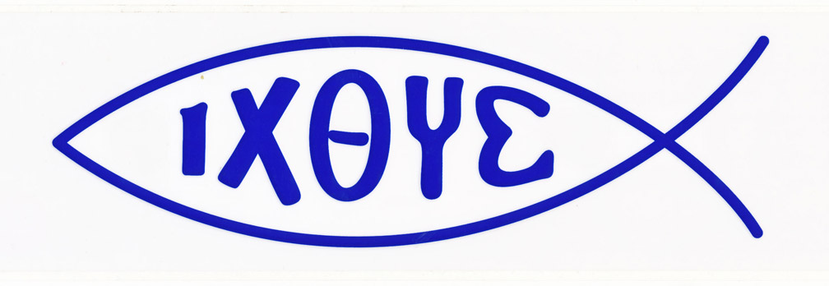

Nov: Off to see the Incas at Cusco – a fascinating Spanish town built on still-surviving Inca foundations, Cachicata, and Machu Picchu. And then the Galapagos (Albatross! “What Flavour?” “No flavour; it’s a bloody sea bird”) on the Nat Geog Islander, where we learned about the Zodiacs. Thanksgiving at Carmel with the Marshalls.

Dec: Travel recovery. Impending Xmas panic. The biggest, and most welcome, storm in years, repeatedly. Yes! I get a sore throat, which I blame on Rowena and American Airlines.

POTUS.

May you have a happy celebration of whatever you choose to celebrate. Next year: more travel. Maybe even to the Sybil of Erythrae.
A+R
PS. Sometime-professor sometime-Personal Shopper Auntie Darci, provider of chocolate-covered cherries to the xmaslittarati, has been placed on a Performance Improvement Plan for failing to do anything outrageous enough to make the Xmas letter without said bribery. She promises to do better.

Port Out, Starboard home – a way to minimize the heat on the trip to/from India. Nope. (Acronyms pre-20th century are nearly unknown). Probably from the Romany posh, meaning half, as in posh karoon or half-crown. Hence money, hence expensive, hence posh.
No, not Sir Walter. Not Robert (of Antarctic or Pythonesque Saharan fame) either. Probably General Winfield Scott, aka Old Fuss and Feathers, and Commander-in-chief of the US Army in the Civil War. The Great General weighed in at 300lb.
What the Ozzies call the newly arrived English. Prisoner of Mother England/ Prisoner of His/Her Majesty. Nope. Rhyming slang gets us to Jimmy Grant (immigrant), and to Pommy Grant, being the pomegranate colour of the sunburn on the said newly arrived prisoners. (Highly doubtful, IMO) Or perhaps from pompom on the hat, as worn by the military transporters of said criminals.
At Agincourt (1415), English archers showed the evil French that they still possessed their fingers (ie, had not had them cut off after a previous lost battle) and so could use a longbow. Nope. Nobody cut fingers off captured archers; they just killed them. The sign is modern (post 1900) and exclusively British/Commonwealth. It would not have lain secret for 500 years. The true origin is unknown. Btw: Bush I used the V sign in Australia in 1992, and it was not well received.
From the plumber Thomas Crapper, who in 1880 provided new flushing toilets to Edward VII at Sandringham. Well… he didn’t invent the flushing toilet: that was Sir John Harington, and this john was used by Liz I, who was a tad before Ed VII. Crap comes from Middle French crappe (waste). On the other hand, it was probably the US military who popularized the word (in 1917 in WWI), and they likely got it from Mr. Crapper’s toilets, not from the existing -and seldom used- word. So despite this being a well-known myth, it is probably true.
“Oll korrect”, a joke in the Boston Morning Post in 1839. Maybe, but probably not. Most likely after Old Kinderhook’s 1840 campaign (Martin Van Buren, from Kinderhook NY) . Less likely: Choctaw okeh. Or Scots Och aye. Or Greek όλα καλά.
From NY and LONdon, where it was invented. Nope. Per DuPont: the letters "nyl" were arbitrary and the "on" was copied from the suffixes of other fibers such as rayon and cotton. The name was originally intended to be "No-Run" ("run" meaning "unravel"), but was modified to avoid making such an unjustified claim. Since the product was not really run-proof, the vowels were swapped to produce "nuron", which was changed to "nilon" "to make it sound less like a nerve tonic". For clarity in pronunciation, the "i" was changed to "y".
“Thou whoreson Zed, thou unnecessary letter!” (King Lear) Webster decreed it should be pronounced zee in the US, but it was also pronounced zee (and zad, zard, ezod, the Scots izzard, and uzzard) in England in 1677, so it’s not just Webster’s fault (although color, theater, and -ize, are).
The Black Death. Nope. The (1350) song/plague explanation didn’t start until 1961. 600 years of silence on the issue would be surprising. And there are plenty of variations of the song without reference to sneezing, or posies, or pus, or death.
There is no doubt that early Christians adopted the pagan fish symbol (from China/India/Egypt), and there is no doubt they used the Greek word ΙΧΘΥΣ. How and when the Greek acrostic “Jesus Christ, Son of God, Saviour” based on ΙΧΘΥΣ came to be is not clear. The best story is that St Augustine (ca 400AD) got it from the Erythraean Sybil. See http://www.johnsanidopoulos.com/2010/12/erythraean-sibyl-and-her-prophetic.html. And she wrote it hundreds of years before Jesus(!)
President Of The United States. Not the West Wing show, despite the Internet. Not the perfect passive participle of Latin poto, I drink. Yes - a label on the telephones in the Nixon White House. But actually, a rare pre-20th© acronym invented to save time on the telegraph (1895). Also SCOTUS.
Pay attention!

