2016 – a Year that will live in Infamy.

“Make Christmas Letters Great Again” – Donald J Trumpusconi
This year, in keeping with the times, there are random ill-conceived thoughts, unarranged into complete chaos. If Twitter didn’t have that annoying 140 limit, I would have sent it by that.

And there is a quiz. Nice and easy. True/false. Oh, the topic? You figure it out.

If Xmas letters are supposed to make you smile, this may not.

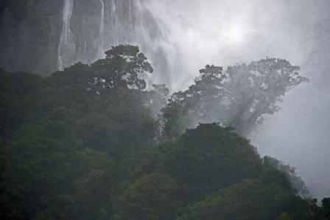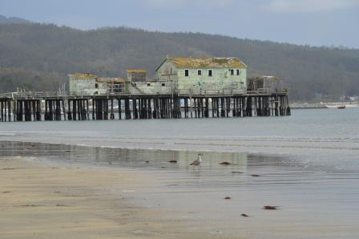

Jan. The year started with a day trip to SF with Alison and Colin, who once went to a certain University. It rained (this is good). It snowed on the Lick Observatory, on my birthday, no less. But not down here in the tropical SJ flatlands.

Pope Francis Shocks World, Endorses Donald Trump for President, Releases Statement

An ‘extremely credible source’ has called my office and told me that Barack Obama’s birth certificate is a fraud.
Feb. We went off to the land of the hobbits, my ancestors, with usual travel companions Alex and Roxanne, and a new Apprentice candidate, Ann, who pruned the roses of the B&B we were staying at and so made the cut (ahem). We took helicopter trips to a volcano and a glacier; I sand-surfed on, yes, sand; we saw penguins and bagpipes (but not together); and gannets and old cars and geothermic everythings; and hobbit houses but no hobbits; met niece Natalie again; and drank wine. Yes we did.

Trump’s history of corruption is mind-boggling. So why is Clinton supposedly the corrupt one?

You know, it really doesn’t matter what the media write as long as you’ve got a young, and beautiful, piece of ass.

Mar. We went to the Aquarium and Capitola and Pillar Point. Giant (briefly-) Inflatable Easter Bunny came out. He is now 38? Years old, which is older than me.

WikiLeaks CONFIRMS Hillary Sold Weapons to ISIS

I will build a great wall – and nobody builds walls better than me, believe me – and I’ll build them very inexpensively. I will build a great, great wall on our southern border, and I will make Mexico pay for that wall. Mark my words.

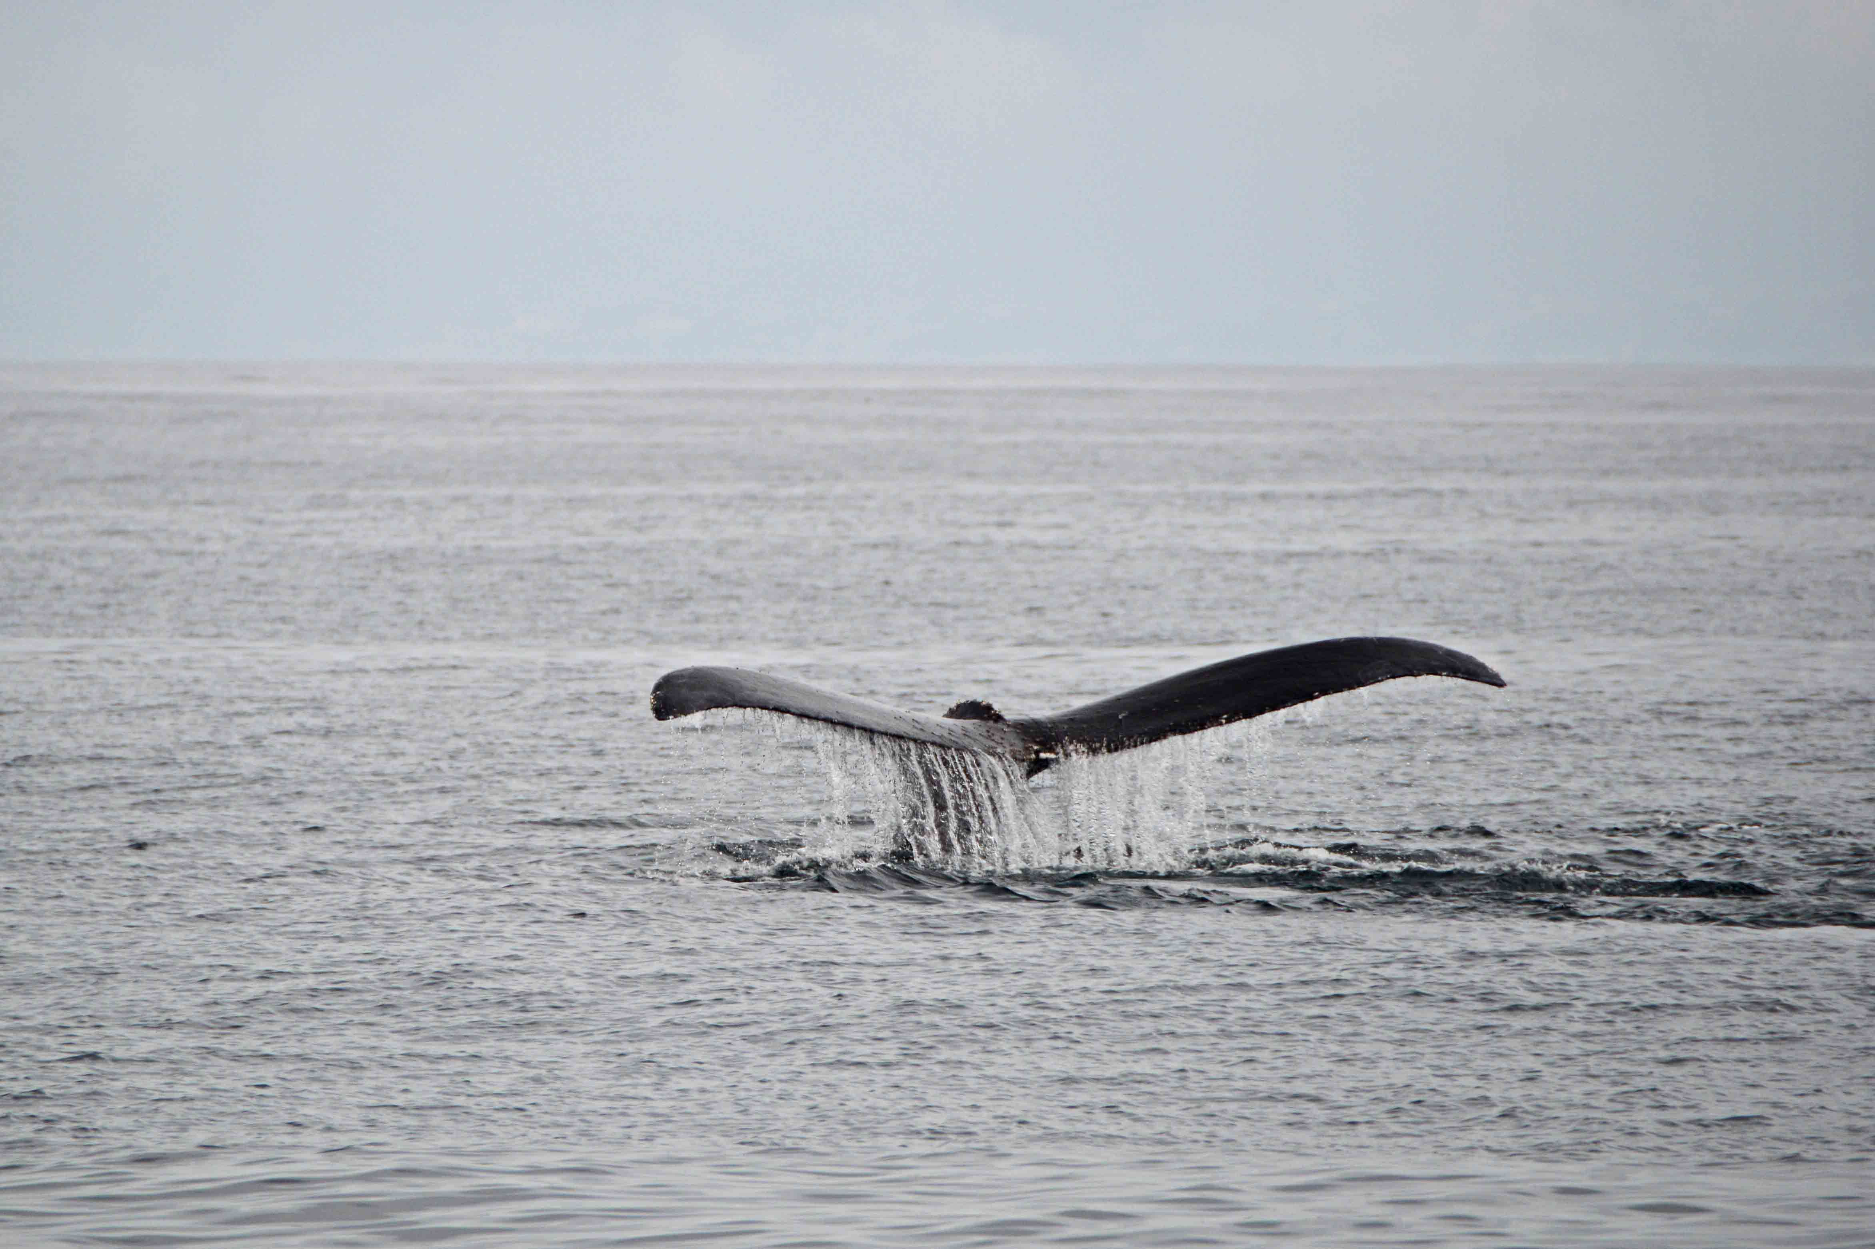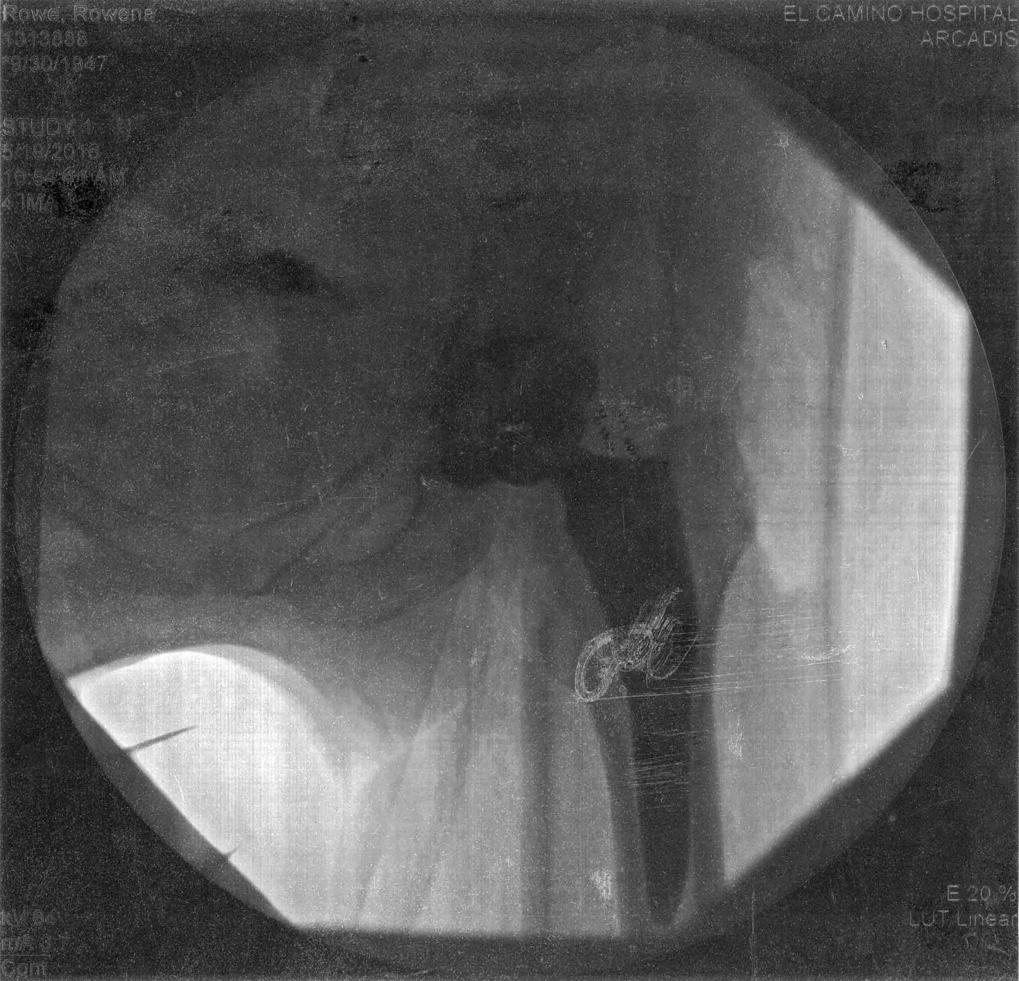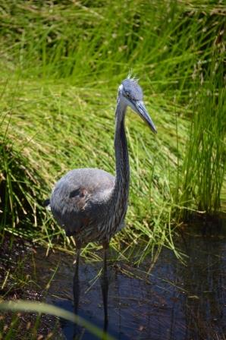

Apr. We went whale watching with GordyMac. Monterey Bay continues to amaze everyone: orcas (not seen yet by us), a blue whale (ditto), thousands of dolphins. We had a hummingbird nest, with eggs, but it failed. Sad! We visited Ian and Cheryl, and came back through the Carrizo plain, which would have been covered in wildflowers if we’d been there two weeks earlier.

IT’S OVER: Hillary’s ISIS Email Just Leaked & It’s Worse Than Anyone Could Have Imagined

One of they key problems today is that politics is such a disgrace. Good people don’t go into government.

May. The big news was that Rowena finally got a new plastic/platinum/cubic zirconium/kryptonite hip. She tossed her walker (unused) the next day, never had crutches, and it has all been a positive experience. For the mandatory walking, we circumnavigated Lake Almaden a few times, inspecting the wildlife.

Just Read the Law: Hillary is Disqualified from Holding Any Federal Office

My IQ is one of the highest — and you all know it! Please don’t feel so stupid or insecure; it’s not your fault.

Jun. Lawson graduated from kindergarten. Both grandchildren joined summer swimming – de vu all over again, from the 1980s. Circumnavigation continued.

Stop Pretending You Don't Know Why People Hate Hillary Clinton

People love me. And you know what, I have been very successful. Everybody loves me.

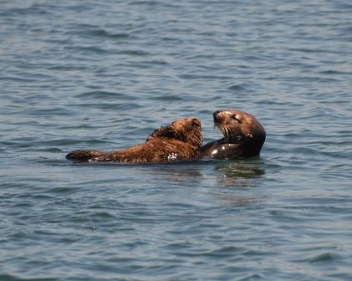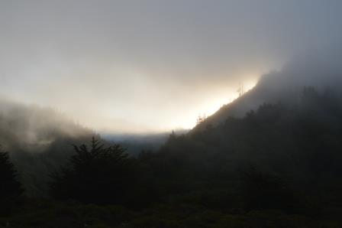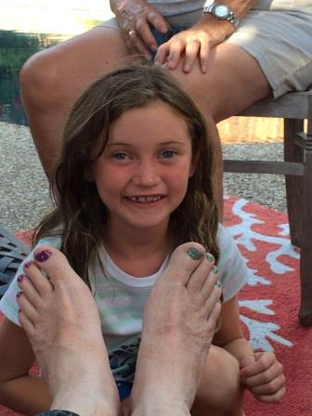
Jul. We went on the first boat trip of Elkhorn Slough, after 36 years. Sea otters by the podful. We will not wait another 36 years. Neve painted my toenails. As part of the now-despised science, I have to report that my toenails have since grown out by about half. So it’s over a year to grow a new set. Take that, toenail deniers!

FBI Agent Suspected in Hillary Email Leaks Found Dead in Apparent Murder-Suicide

The point is that you can't be too greedy.

Aug. A few days in foggy Mendocino (sing along now!). We went to the Exploratorium to see the Strandbeests. If they come to an exhibition near you, go! Of course, vintage car racing at Laguna Seca.

FBI director received millions from Clinton Foundation, his brother’s law firm does Clinton’s taxes

I have an attention span that’s as long as it has to be.

Sep: We had a fire on the hill – a long way off. Off to Jellystone, where we did not see Yogi. But bison, elk, pronghorn, and meese. And our second set of geothermic everythings. This was the last week before they close for the winter. Yes, it did snow.

Melania Trump’s girl-on-girl photos from racy shoot revealed

Beautiful, famous, successful, married – I’ve had them all, secretly, the world’s biggest names, but unlike Geraldo I don’t talk about it.

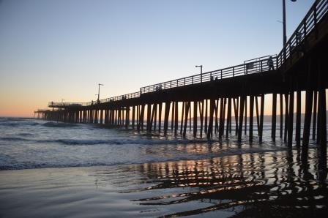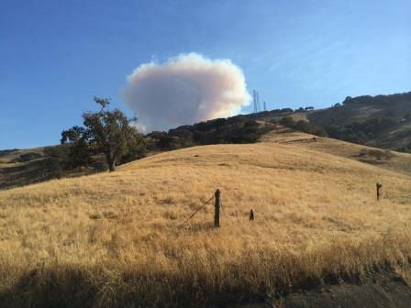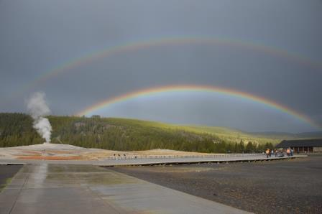

Oct: Off to see Iain and Cheryl again. Cambria in the rain. Followed immediately by Maui. We need to catch up on our hip-interruption time. Then the pumpkin patch.

ISIS Leader Calls for American Muslim Voters to Support Hillary Clinton

I think apologizing’s a great thing, but you have to be wrong. I will absolutely apologize, sometime in the hopefully distant future, if I’m ever wrong.

Nov: Off to Lodi to see the wintering Sandhill Cranes. And Thanksgiving with the outlaws in Carmel, where the sun did set, rather nicely.

Hillary Clinton In 2013: “I Would Like To See People Like Donald Trump Run For Office; They’re Honest And Can’t Be Bought”

Beautiful, famous, successful, married – I’ve had them all, secretly, the world’s biggest names, but unlike Geraldo I don’t talk about it.

Dec. We were signed up for Cuba, and they cancelled the trip on us. Not happy!
We had to stay home and plan/shop for Xmas early, which, in an act of civil rebellion, we did not do.

BREAKING: Fraudulent Clinton Votes Discovered By The “Tens Of Thousands”

And it just seems that the economy does better under the Democrats than the Republicans.

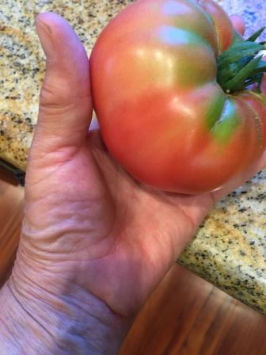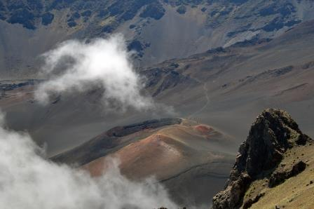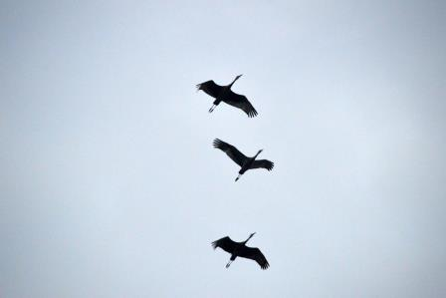

Jan 2017. The start of 8 years of hell. Can’t wait.
I think Bush is probably the worst President in the history of the United States. -- DJT

Yes; so far.

Now look over here at these shiny objects….

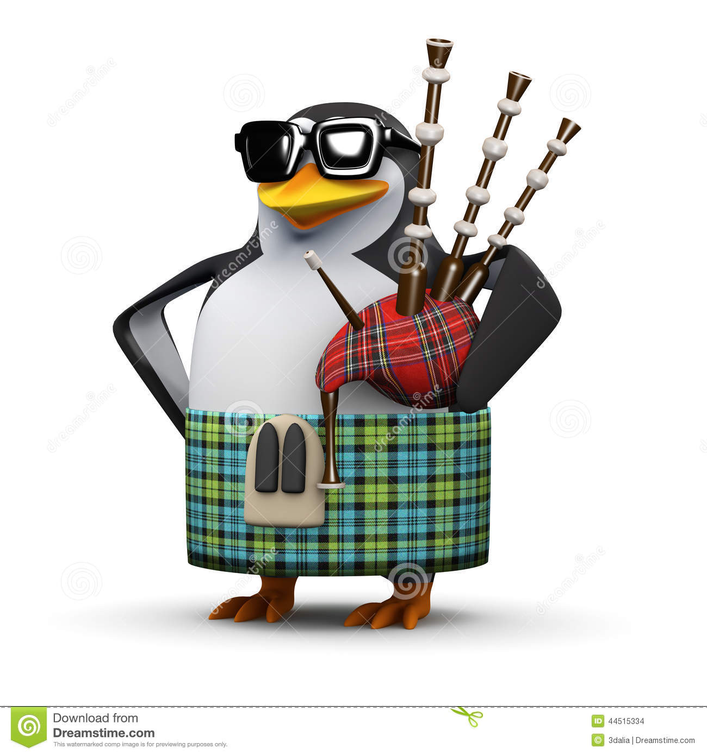

The following have paid in cash or tangible assets (ie, bribes) for mention in this newsletter or elsewhere: Vladimir Putin, Darci Arnold, the FBI.

Quiz: These were the stories from Aug-Nov which were the most commented/shared/liked in Facebook. Feb/Jun/Sept were true; the rest were fake news, with an audience of 16 million. The quotes are all by you-know-who, the Supreme Leader.

