Xmas 2017

“Lock him up. Lock him up.”
“We’re now having the Xmas letter—and we had the most beautiful letter that you’ve ever seen.”

Yes, an entire edition without politics (well, except for a few cheap shots at Agent Orange).

As anarchy, oligarchy and kakistocracy continue unabated, we look at the next steps in returning the country to the Traditions of Old. Quiz: which country shall we be stealing the non-Santa traditions from (hint: it won’t be Mexico or anything non-white-Christian).

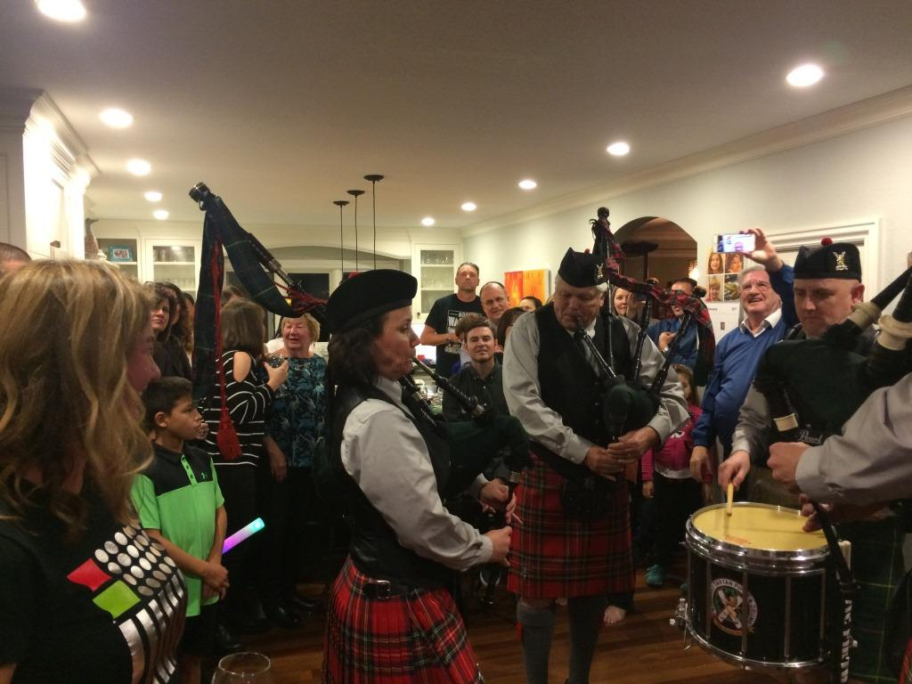
Jan: We go birding in northern CA, during the biggest storm of the century (so far). Hotel cut off by floods. Fiona turns *ty. Of course there is a band. Of course there are (multiple) bagpipes. Duh. We leave for Hong Kong, where we celebrate my 29th birthday.

Quiz: The Krampus (not to be confused with the Kraken), a horned half-demon, half-goat and pal of Santa, who steals small children and beats them. He seems not to have Orange hair. Once banned by the Fascists for being a Social Democrat; look out, Bernie.

Feb: We enjoy a few days in HK, including New Year’s Day, Chinese calendar. We go off to Siem Reap in Cambodia, to see Angkor (and many other) Wats. Staying at the Raffles Hotel. After a mistakenly chosen Morning Glory meal, I get a touch of the intestinal perturbations on the last day. I have a shower. I leave the shiny and beautifully tiled floor wet. Rowena goes in, slips, and falls with what turns out to be a hairline-fractured pelvis. We continue with the cruise down the Mekong, Rowena walking between the cabin and the restaurant, but no further. At Saigon, we give up (missing Hanoi and Halong Bay) and come home. She is mended now.

La Befana, a witch with mandatory broomstick, who comes down chimneys. Leaves sweets or coal. Suffers from total lack of originality in the script- probably by JJAbrams.
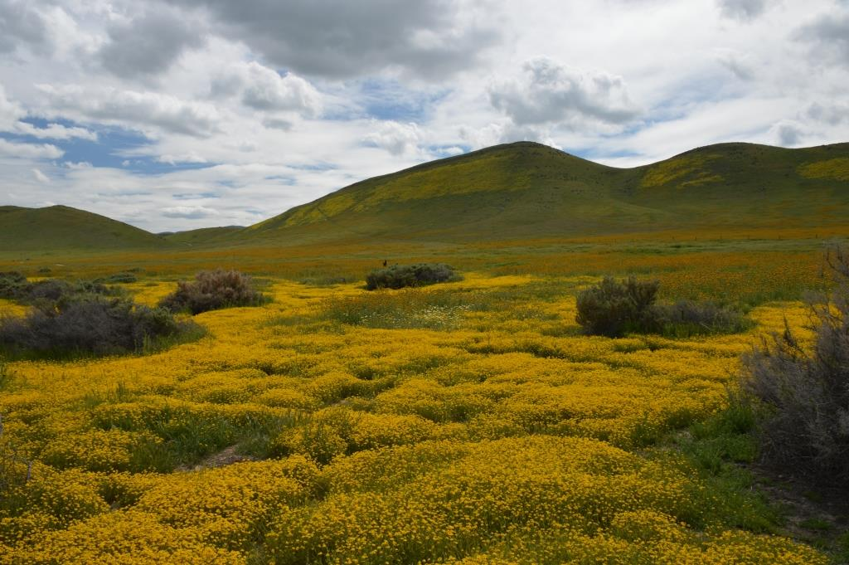
Mar: In 1984, or thereabouts, I planted Iain and Fiona’s two tiny live pine Christmas trees on the hill. After this winter, one tilts measurably, threatening the bocce court, and has to be removed. It’s not tiny any more. The winter rains have their good points. We return from a trip to see Iain and Cheryl via the Carrizo plain, 50 miles inland, famous (and justly so) for its wildflowers.

Belsnickel. Leaves candy or takes the kids into the forest. In Hollywood, they call this a ‘reboot’.
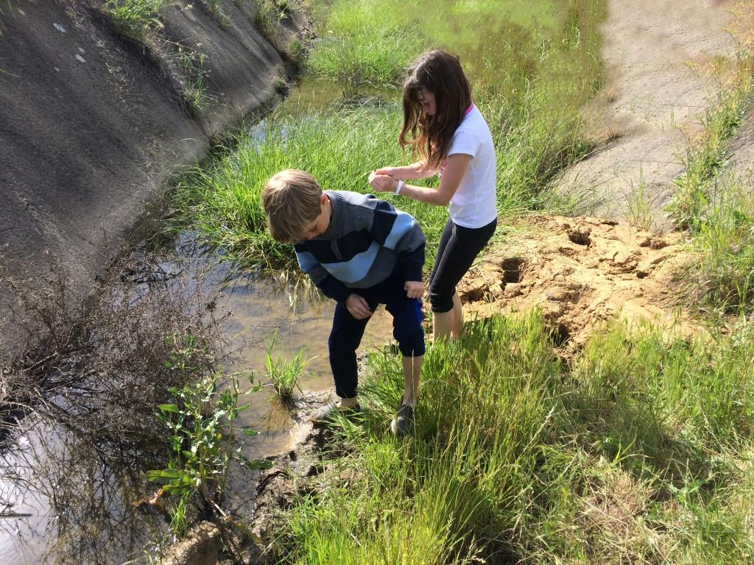
Apr: Tim has a birthday without bagpipes. Poor Tim. Me, Darci, and children go on my first ever political march – the March for Science. The US Govt immediately takes notice and starts believing in Climate Change. Tadpoles are discovered.

The Caganer. There are Nativity Scenes, and then there are Nativity Scenes. In this one, the Caganer is a little guy who is caught in the act of pooping, and immortalized thus. You can of course now get china Cagoners with the body of the Pope, a nun, George W, and you know who (or maybe you don’t).

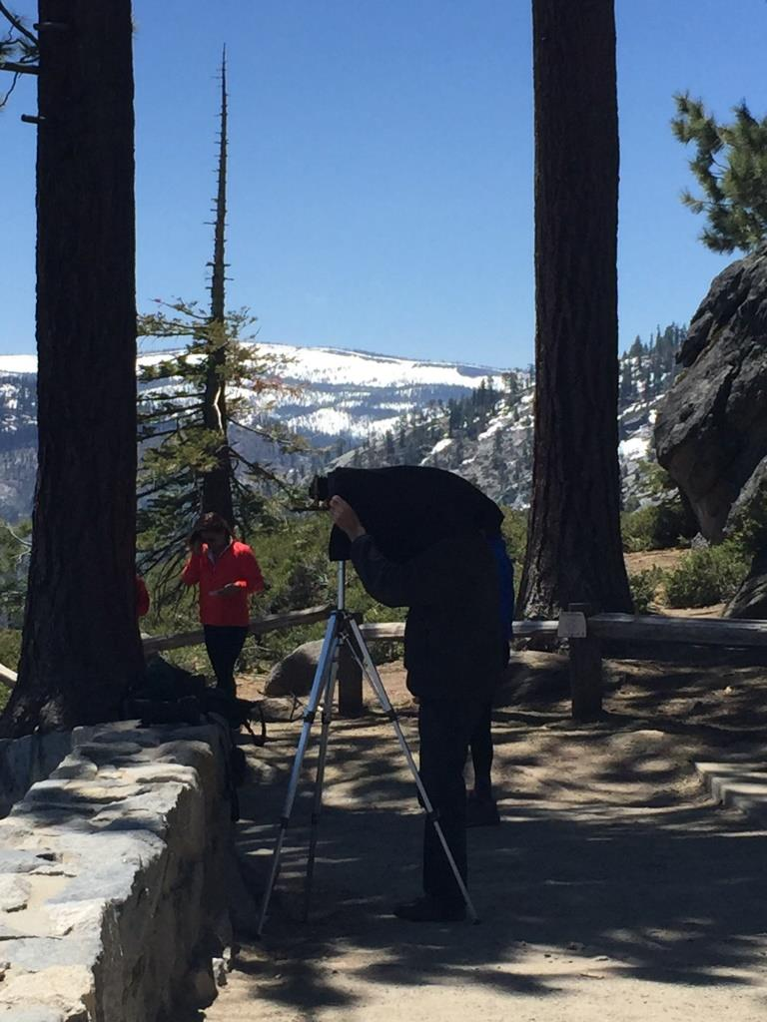
May: We go to Yosemite, where the waterfalls are turned on after that winter, with Grandpa’s old camera. I screw up bigtime with the film; all is lost.

They eat deep fried caterpillars of the Emperor Moth instead of turkey.

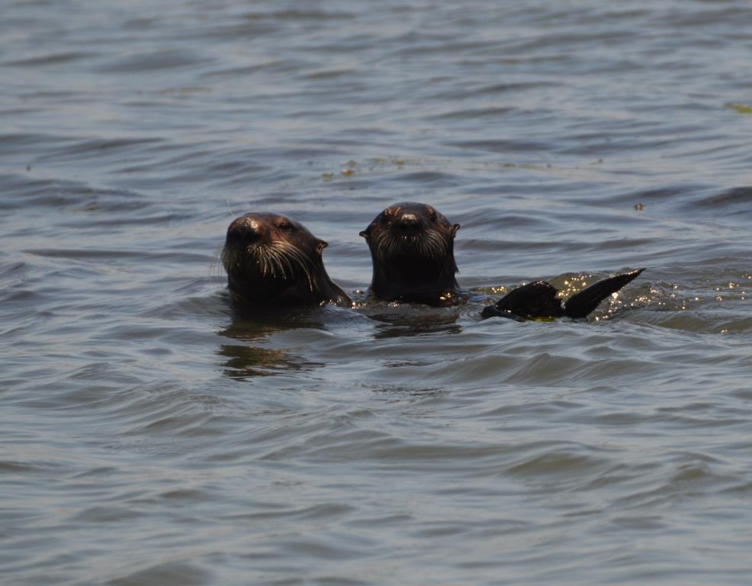
Jun: Our Xmas gift last year from Fiona was a trip to see Hamilton. I’m not a fan of musicals, and hate rap, so I was a tad worried. It was, however, wonderful. We take now 9-year old Neve to Elkhorn Slough to see the wildlife – especially rafts of sea otters. We go to see the Glenn Miller orchestra, some 49 years after I saw it the first time.

Continuing the poop theme (much loved by a 6-year old I know): Tio de Nadal. This is a Yule Log that poops presents, when being beaten by children with sticks (in a role reversal from most stories), as long as this song is sung: Shit log, Shit nougats,Hazelnuts and mató cheese,If you don't shit well,I'll hit you with a stick, Shit log! This seems like a worthy thing for a grandfather to teach.

Jul: Off to Kauai with friends Alex and Roxanne, 31 years after the last time we were there. This time it was dry. Then off to the UK to see Marjorie and Andrew and an assortment of GenX relatives. Orkney and Shetland, puffins and a tattoo. (The other kind).

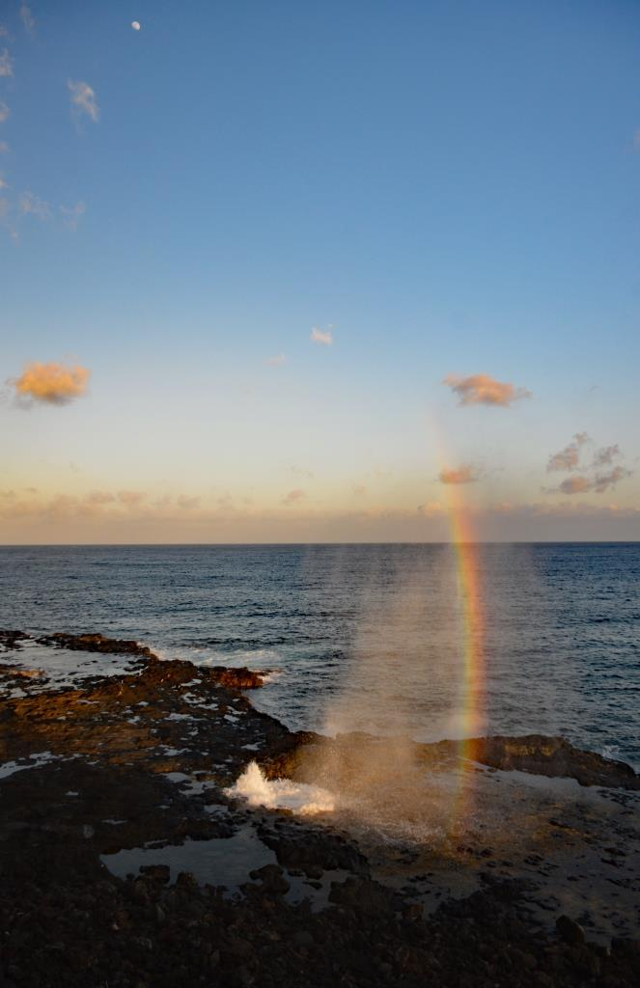
The population goes to Mass on roller skates.

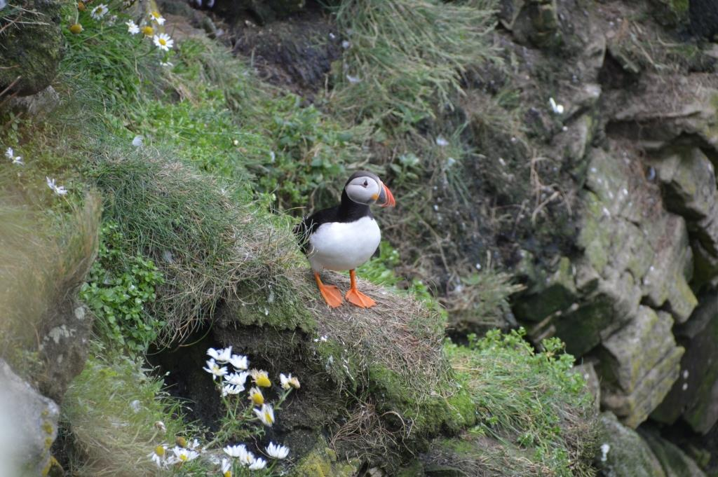
Aug: In an unexplainable mystery for the FlatEarthers, we have an eclipse. Partial by us, but still The Neighbourhood got Excited.

Zwarte Piet, aka Black Peter. Companion to Santa. Looks like a Golliwog, a word I’m no longer allowed to use. Black because he is a Moor, or has soot from the chimney on his face, although Santa never does. He hands out sweets, or deports children to Spain, which seems like a rather counter-productive punishment.

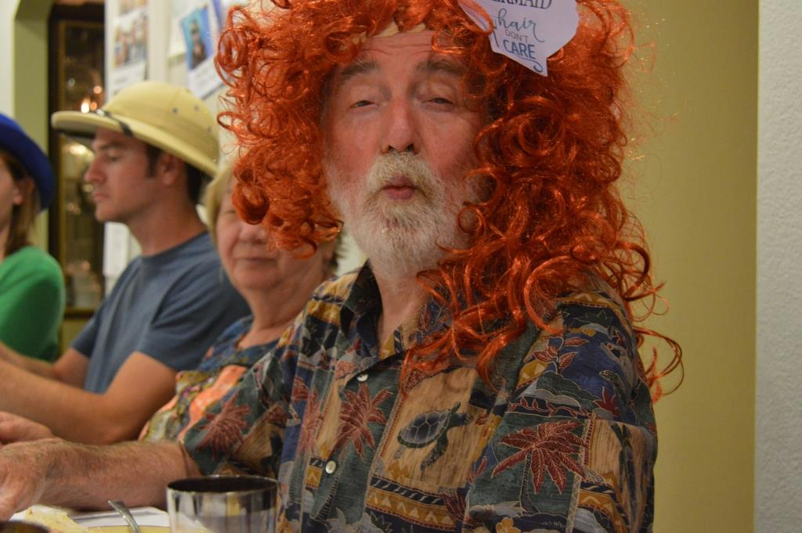
Sep: Our usual Block Party. Whale watching in Monterey. It was a close thing. No lunch for me, but I retained my breakfast. We visited MT Umunhum, a 1980s-style Air Force Radar Station at the top of the mountain, with splendid views of the valley. Rowena turns *ty, which is not the same *ty as Fiona’s *ty. By special request, there are no bagpipes.

Where do they eat KFC Fried Christmas Dinner. Yes, that KFC. Yes they do.
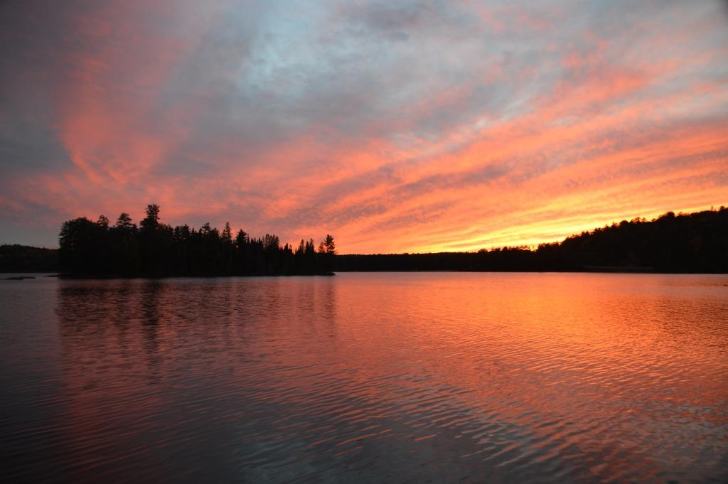
Oct: Off to Ontario in Canadia to see Fall and friends and relatives. I am a Halloween squirrel. I love squirrels. As part of my social duty, I often relocate them to holiday homes.

Gryla, a mountain troll. Boils and eats naughty children. Thrice married (like you know who). Thirteen tails. Has a cat.

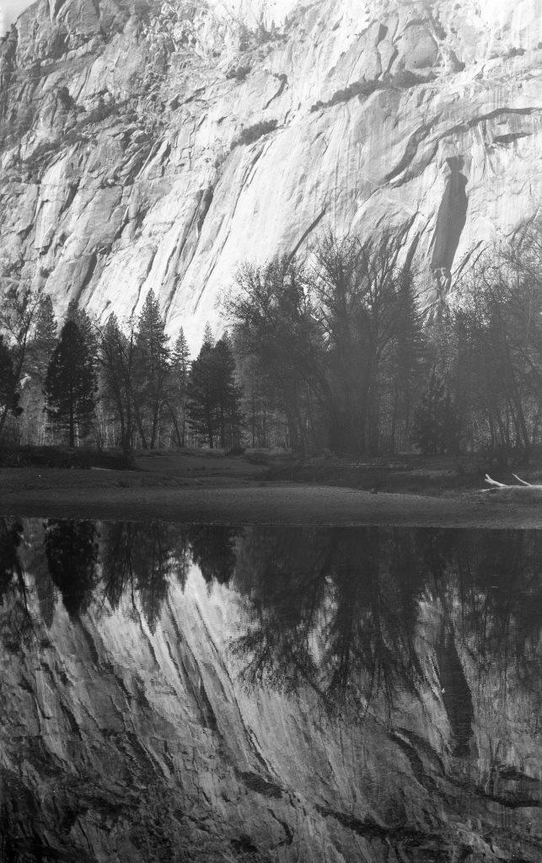
Nov: Yosemite, for try#2 with the old camera. This time I screw up differently, in many ways, but there are still 2 acceptable photos from the allotted 12. We have a visit from The Aussie Doctor, so we take him whale watching – this time Blue Whales.

The jólasveinarnir or Yule Lads. The sons of Gryla, which makes it one per tail, if I’ve done the arithmetic right. They arrive 13 days before Xmas. Typical football yobos. They have funny names with many diacritical marks, names too long to show here.

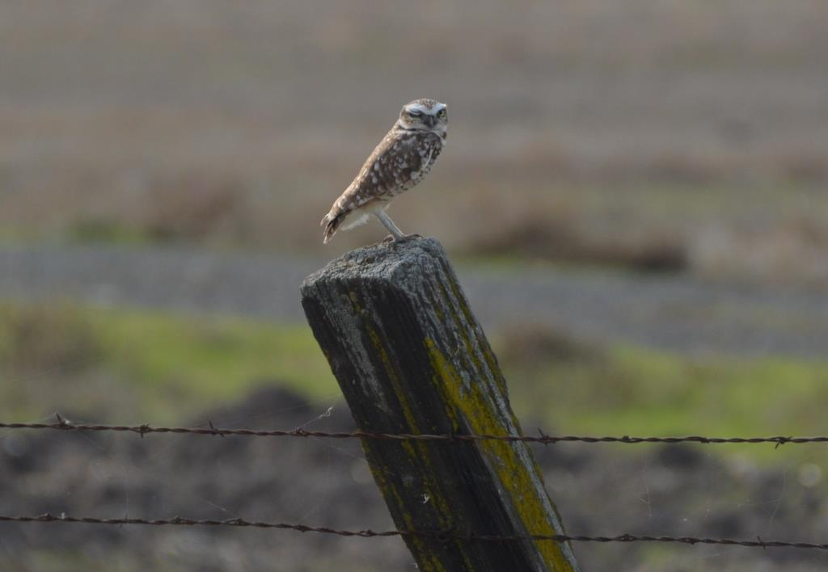
Dec: Learning little, we again go birding, to see the Sandhill Cranes around Lodi. This picture isn’t one of them.
Alabamans don’t elect Judge Roy Moore, a man who steals young girls from the mall. Don’t ask what he does with them.

As Bill O’Reilly wouldn’t say (but Fox News did): Happy Holidays.

May we all survive another year of The Tweet Twit.

Banned by the Puritans in England in 1647 and in Massachusetts in 1687, because of that whole heathen Saturnalia thing. Shops were ordered to stay open, which would have pleased Ye Olde Walmarte. “For preventing disorders arising in several places within this jurisdiction, by reason of some still observing such festivals as were superstitiously kept in other countries, to the great dishonor of God and offence of others, it is therefore ordered by this Court and the authority thereof, that whosoever shall be found observing any such day as Christmas or the like, either by forbearing of labor, feasting, or any other way, upon such accountants as aforesaid, every person so offending shall pay of every such offence five shillings, as a fine to the county.” The War on Christmas ended in 1870 when it was declared a Federal Holiday, after Fox discovered that the Founders had wisely written a mandatory Judeo-Christian celebration into the Constitution.
Santa has origins in the NSA (He sees you when you're sleeping, He knows when you're awake, He knows if you've been bad or good…) . Before that, the Christian St Nick , who was Turkish. Before that, a chap called Odin delivered toys and candy by sneaking down chimneys. If you were good. A lot like the pagan Finnish Joulupukki, and similar characters all over Europe.
Germany, Austria, from pagan Norse before St Nick got invented.
Italy, esp. Rome. Supposedly Christian, and involved with the Magi, but seems under-represented in the KJV bible. In Norway, through a different? myth, they hide broomsticks in case a similar witch finds them.
Germany, and now Pennsylvania. JJAbrams would make a hash of this movie too.
Catalonia. No wonder they want to be independent. And see http://www.lavanguardia.com/r/GODO/LV/p3/WebSite/2016/09/26/Recortada/img_lferro_20160926-113729_imagenes_lv_terceros_caganers_trump-k4rB--992x558@LaVanguardia-Web.jpg
South Africa.
Also Catalonia.
Venezuela. Although I think they’re practicing to immigrate, but the Wall will stop them. Can’t climb a wall on roller skates.
Belgium/Netherlands. They still dress in blackface, fighting claims of racism and slavery. They need to switch to orange faces – much scarier. (And they are, after all, Orangemen)
Japan. Undoubtedly pagan.
Mentioned in in the Edda, 13th c. Iceland. I’m guessing pagan.
Obviously Iceland. What is with these Icelanders? Two of the lads are called Donald Jr and Eric.
Let’s not get into that.
One of the many mass hypocrites this year. And worse.

