2018 – the survival

The concept of global warming was created by and for the Chinese in order to make U.S. manufacturing non-competitive -- DJT.

In celebration of the US surviving [so far] despite significant odds, this year’s quiz is all about cures for various diseases.

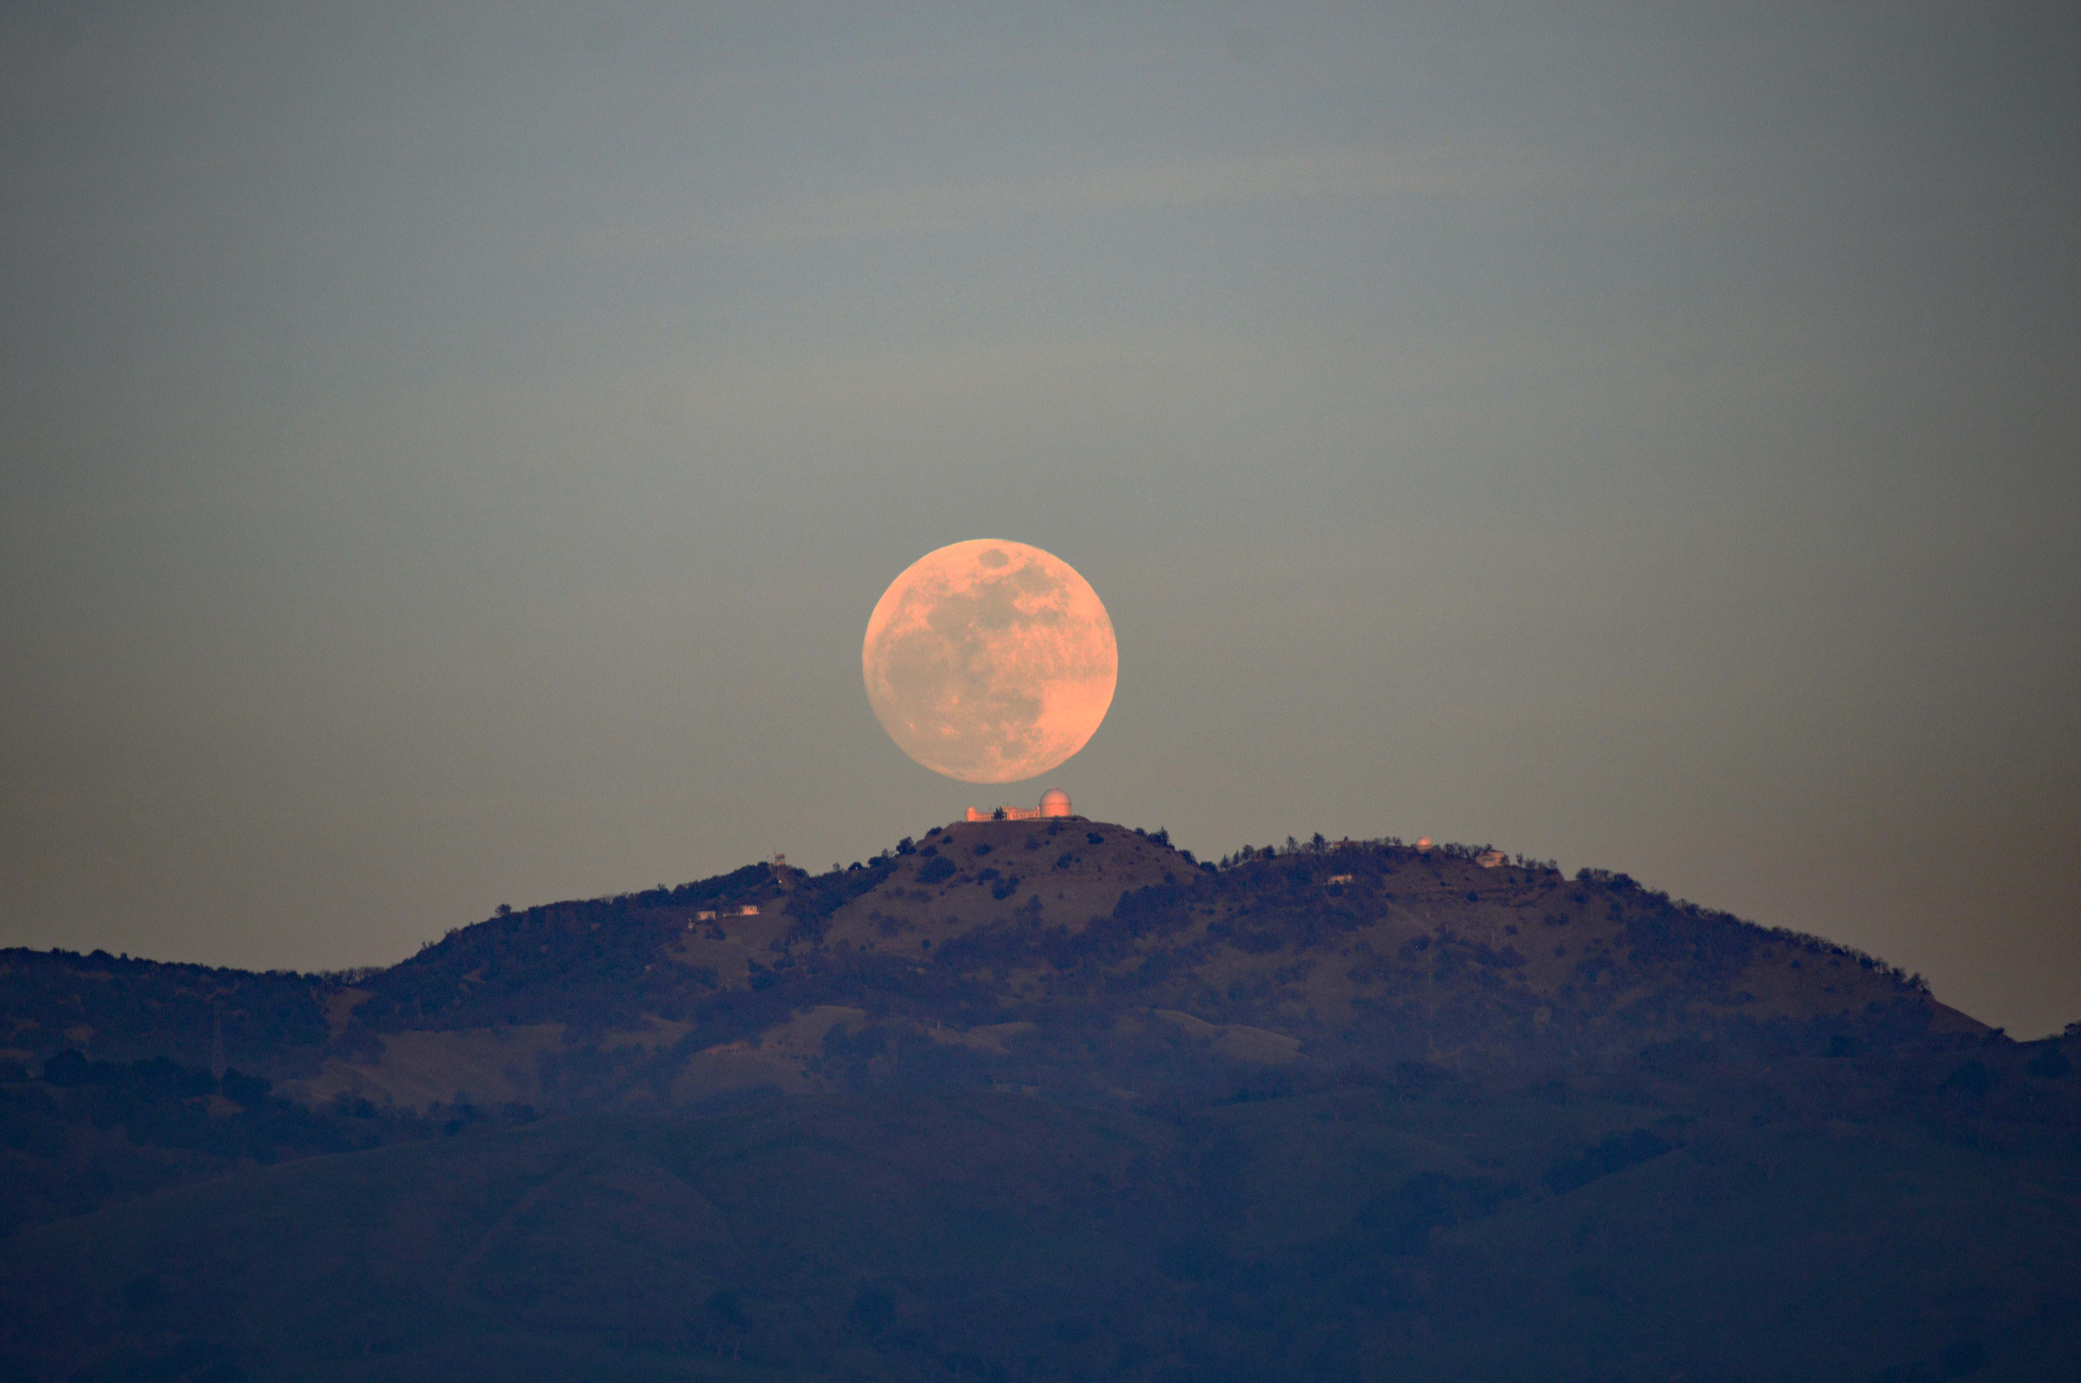

Jan: Due to a conspiracy, we arrive home from a movie to discover my sister Marjorie (and Andrew) in my house. Apparently, it was soon to be my birthday. And apparently a big one. Why is 28 regarded as big? The supermoon mis-judges things, and arrives a day before my birthday.

What was the cure for unbalanced humors (ie, the contents of the human body - yellow bile, black bile, phlegm and blood)?

Feb: we see orcas and grey and fin whales off Monterey. We visit Mt Umunhum, an old radar station on the top of a local mountain. After many years of work, it opened and then the tower almost immediately closed because of unexpected asbestos. Sigh.

What was the Roman cure for epilepsy?

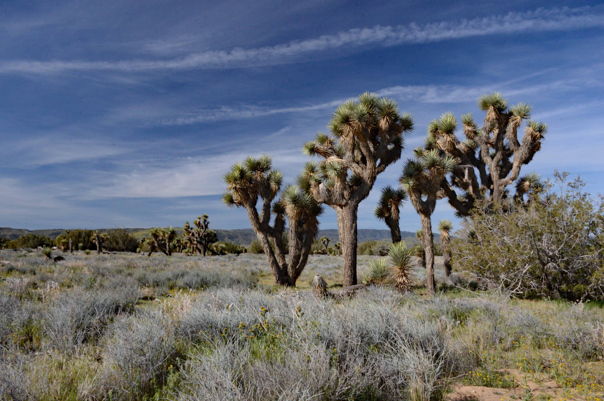

Mar: a sighting of a bobcat on the hill – first one since the big hillside fire of many years ago. And a sighting of the once-young Scottish Doctor Neil, and his still-young Australian doctor spouse Teresa.

What was the all-purpose health food of the 12th century?

Apr: wildflowers. Giant Inflatable Easter Bunny (now aged about 41 years). We go to Joshua Tree National Monument to see the Joshua Trees (duh – but they’re better outside the park), cactus, and poppies in the Antelope Valley, of which there were (almost) none this year.

What was the cure for night-time teeth grinding?



May: In their second California appearance this year, Andrew and Marjorie turn up for the graduation of son and about–to-be Doctor James at UCB. FYI: it is hot in the UCB stadium in May. We go to the gardens of Filoli, and see old planes at Moffett Field.

What did Charles II use King’s Drops for?

Jun: Swimming starts again for the grandchildren. We are destined to miss a few events this year, because … we go to incredibly beautiful Iceland, over the solstice, circumnavigating the island clockwise. 2377 miles, including detours (You could do it in 800 miles, but why?)
What was a cure for warts, cysts, and haemorrhoids in the 17th C?



Jul: we go to friend Ann’s birthday in Ottawa. She is 2.85714285714 times as old as my 28. Nephew GordieMac, wife Lucy, and their small people get to experience the flavour (there’s only one) of Gilroy. While they are off donating money to the Disney Corporation in LA, we visit (with friends Corey and Darci) the World Famous Mystery Spot in Santa Cruz, where gravity doesn’t work right. It’s a mystery! (It’s also a mystery why we’d never been before, after 38 years here.)

What was the 19th C cure for (variously) toothache, migraines, depression, and impotence.

Aug: Capitola with the now impecunious Gordiemacs. Of course there’s old car racing at Laguna Seca.

What do you give a hyper or teething child?



Sep: We go on a Danube cruise, Budapest to Amsterdam (with extra days in Prague). This would likely have been better if there had been water to cruise upon. We learned we are not River Cruise People.
How do you cure a rapier wound in the 17th C?

Oct: The second bobcat sighting of the year. We go to visit Iain and Cheryl and see scarecrows in Cambria, this time not in the rain.

What do you do if you have leprosy, psoriasis, arthritis or diabetes?

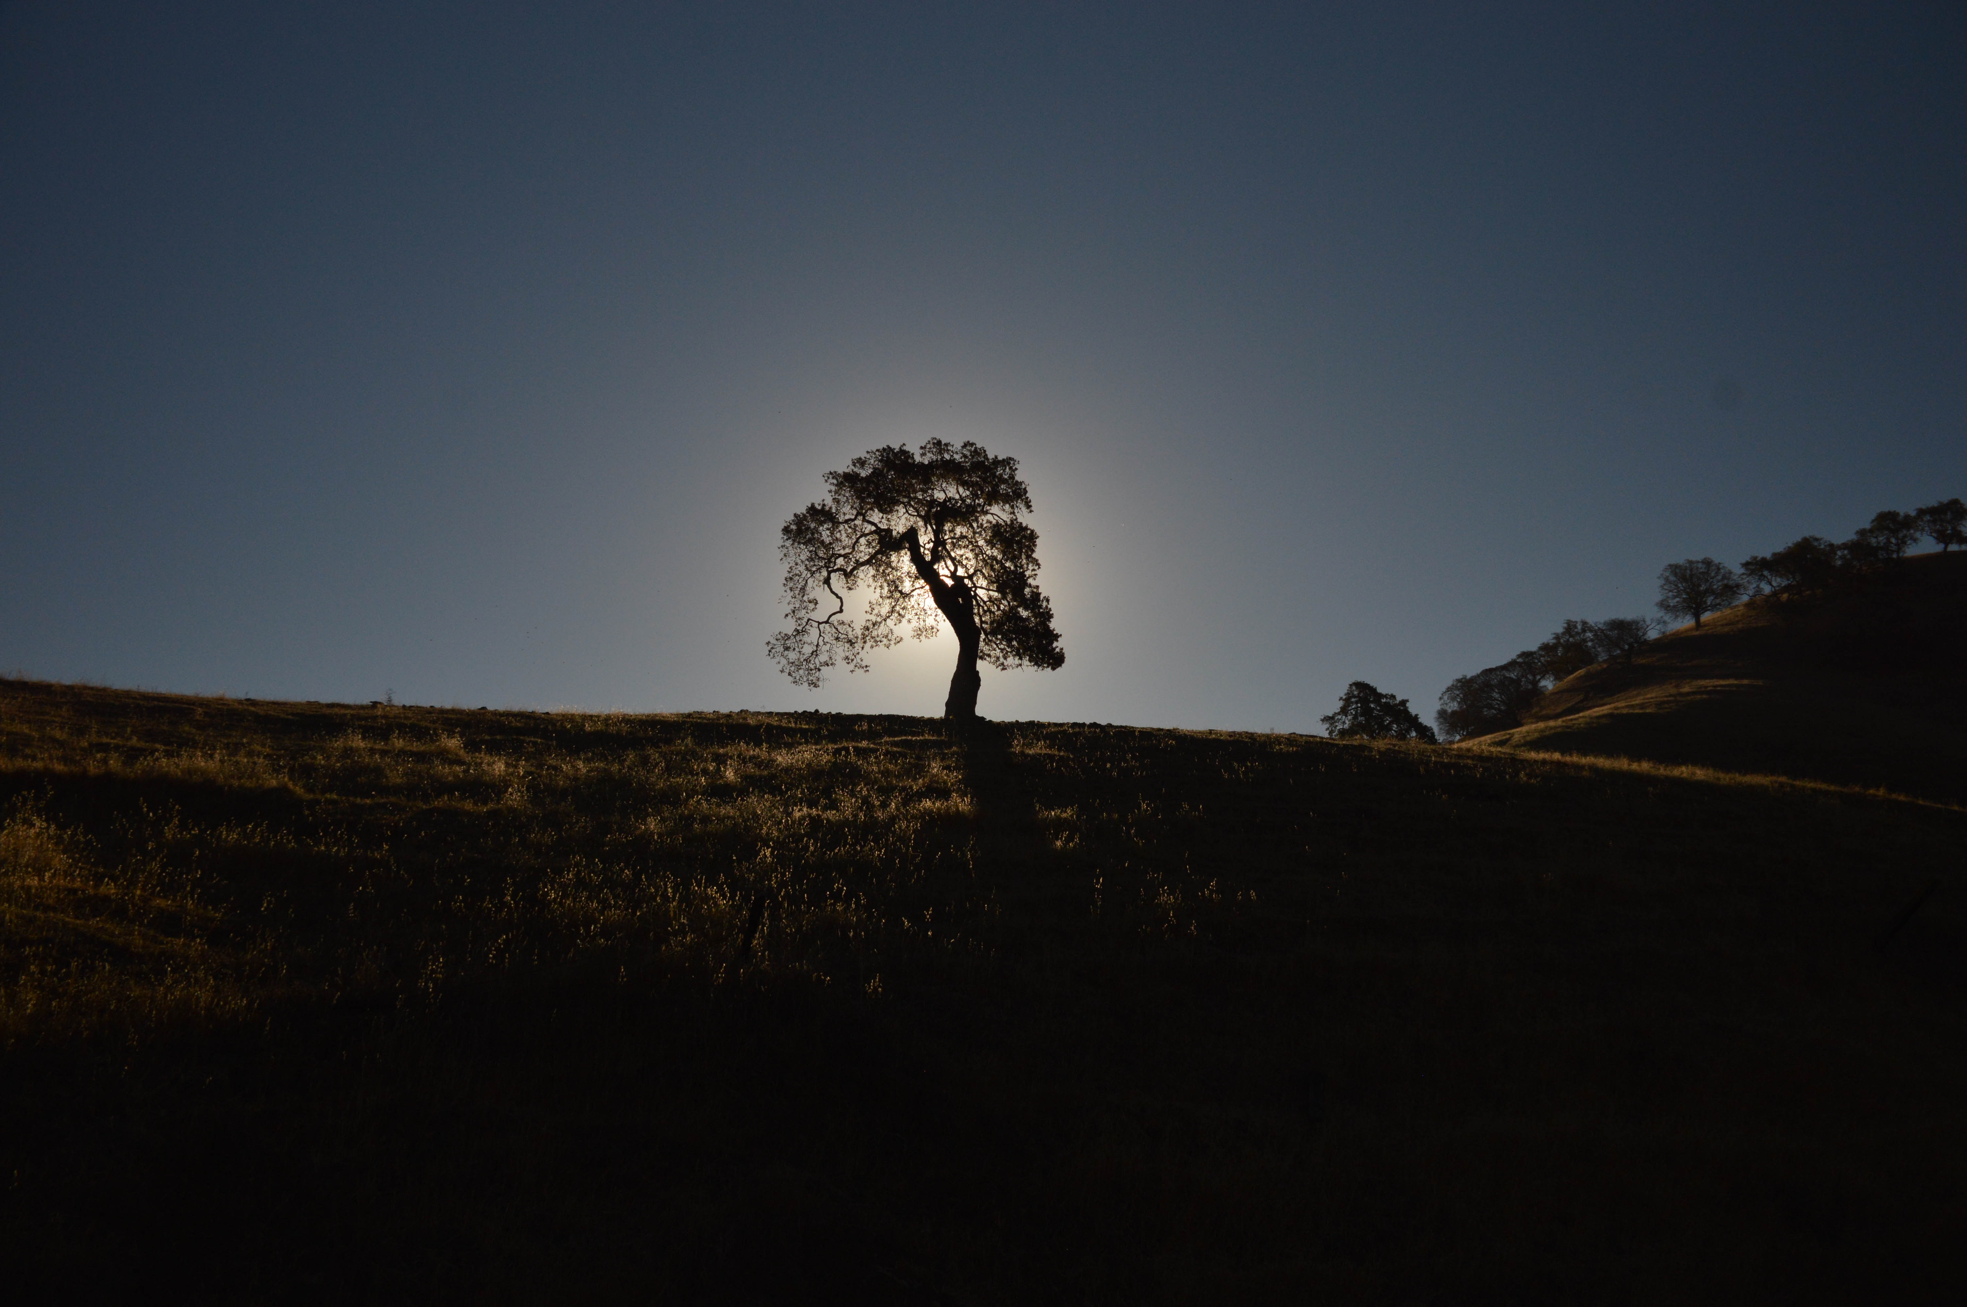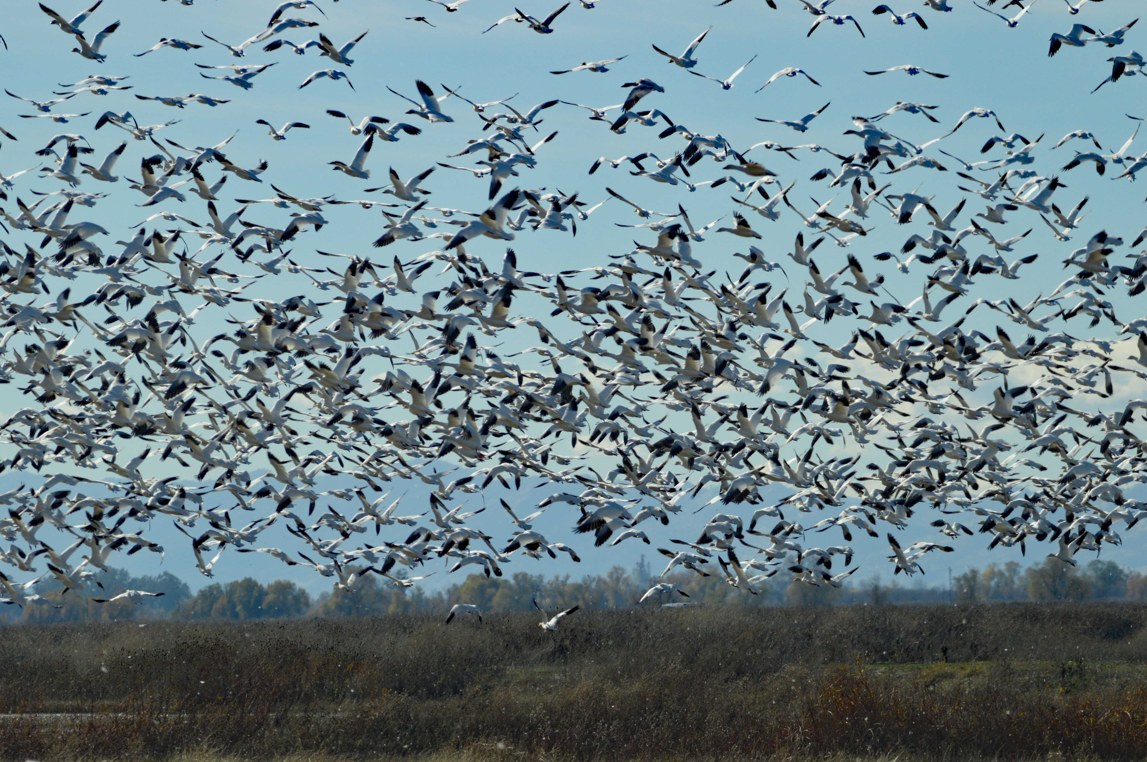

Nov: A fire, likely started by our power utility PGE, burns down an entire town 200 miles north of us. Air all across California is of worse quality than in Beijing. Amazon runs out of masks (but I’m ready for next time). We celebrate Thanksgiving in Carmel with the in-laws.

And if you have sore joints because you’re building a railroad across the US?
Dec: we go on a birding weekend to the delta. We see geese and ducks. By the million. I get a new toy, with which I can photograph coyotes even closer.

What is cured by elephant tusks, rhino horns, shark fins, birds’ nests…..

What cures pathological lying and flagrant narcissism?

Happy 2019 – the year the wheels all fly off the clown car. I either look forward to it, or dread it.

Pics: the supermoon; orcas; Joshua Trees; sunset in SJ; oriole; Skaftafell; Wakefield PQ; Wiley; Budapest by night; bobcat; our tree; geese.

As you might guess, choosing just one idiotic DJT quote was hard.
Bloodletting. Although you’d think that would only solve ¼ of the problems.
Drinking the blood of fallen gladiators.
Mummy powder – ground up (and dug up) Egyptian mummies. Not much different from Gwyneth’s Goop magazine of today, really. Although it all seems to have been a bit of a mistake, since the Mummy (or mumia) had the same name as a type of bitumen (mumia) found in the Dead Sea, which really did have some medicinal properties.
Since teeth grinding was caused by a spirit trying to get in touch with you, you need to exorcise the spirit by sleeping with a handy skull. It’s unclear if the skull had to belong to the dearly departed.
“King’s Drops” were ground up skulls (what’s with this skull thing?), and were used to promote health (Goop again). Also for epilepsy and apoplexy.
A dead man’s sweat. If there wasn’t a dead man handy, you could go down to your local hangman.
Cocaine. First mixed with wine in France as Vin Mariani, it was later banned in the US because of the dangerous and unacceptable alcohol content. When Mr Pemberton created a similar but alcohol-free drink, he called it Coca Cola.
Obviously, Mrs Winslow’s Soothing Syrup. Made from a herbal mixture of morphine, cannabis, heroin, and powdered opium at 1s 1/2d per bottle. Quite a deal, I’d say.
By using Sir Kenelm Digby’s Powder of Sympathy. Mix worms, pigs’ brains, rust, and mummified corpses (again, already!), and apply – this is the key part – to the rapier. By some magical sympathetic process, the wound is healed.
Take a nice dose of Donovan’s Solution, a mixture of arsenic and mercury. Also a handy cosmetic. Or, for malaria or syphilis, Fowler’s solution. Showing how superior Donovan was, Fowler’s brew didn’t have mercury.
Snake oil. And if you use the right snake, it really is an anti-inflammatory.
Nothing. Unfortunately.
Read about the new bottomless Pinocchio here: https://www.washingtonpost.com/politics/2018/12/10/meet-bottomless-pinocchio-new-rating-false-claim-repeated-over-over-again/?noredirect=on&utm_term=.0eb49b2324f8
The best lies of 2018 – and not all Donald’s! https://www.factcheck.org/2018/12/the-whoppers-of-2018/
Nothing. Unfortunately.

