2019

It’s punishingly bad. But it’ll groan on you. Be warned.

“A PERFECT Xmas letter” – DJT.
“I want nothing of the Xmas letter” -- DJT
“Orange is the new Black” – Not DJT, 2016.
Santa Claus' helpers are known as subordinate Clauses.

The 31st edition. (FYI The 31st element is Gallium) (the kitchen on a Roman ship).

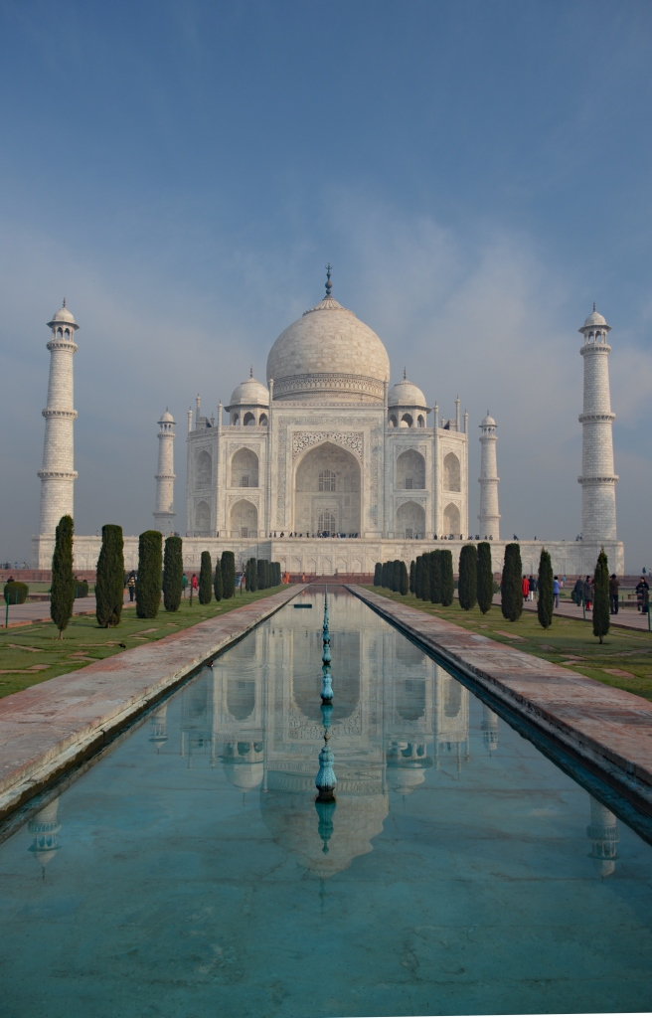

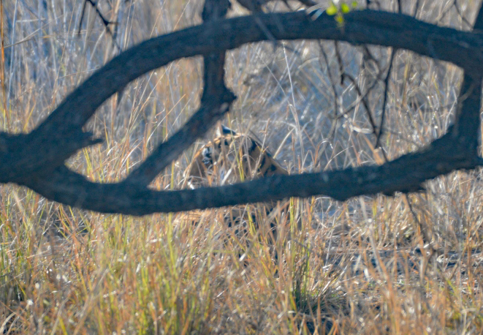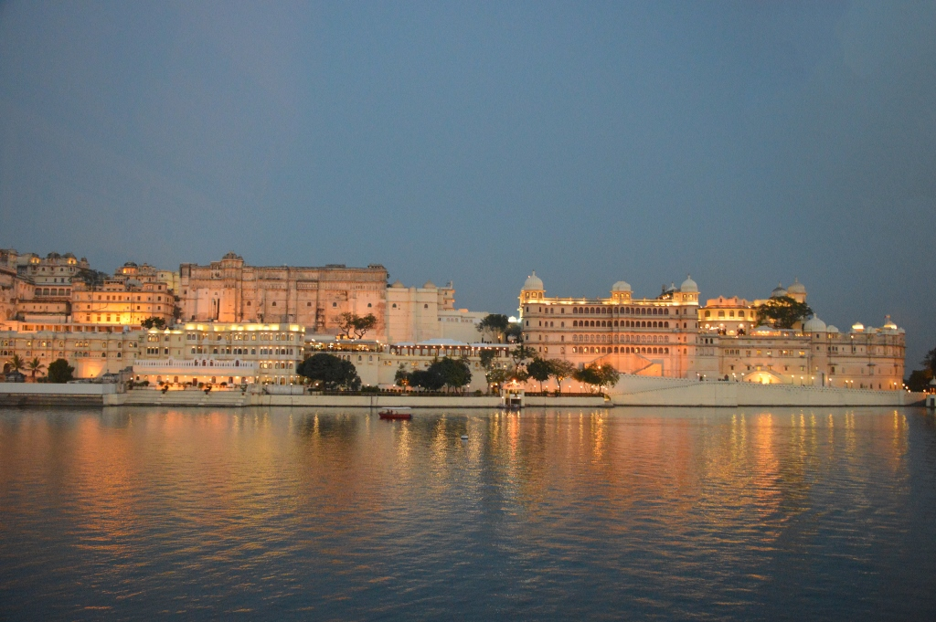
Tiger! City Palace, Udaipur
Jan: On our first Big Trip of the year, we go to Rajasthan, and stay in the Maharajas’ Palaces – the best hotels ever, by far. [To see one of them, watch Octopussy - it’s Roger Moore, so you know what to expect, but it’s actually not that bad. They merged three different places; we stayed at the one in the middle of the lake. The photo is one of the others]. We both see one tiger hiding behind a tree; I glimpse another. But wait—there’s myrrh - the Taj. And we ride camels near the Pakistan border (They didn’t see us because we were camelflaged) And a filthy Temple of rats (been there, done rat). And.. and .. and.

Feb: On our return, the orchids are in flower and the plumerias are alive. To celebrate, Rowena takes the first plumeria photo (of 109 this year, so far). I’m still in the lead with 304 sunsets, though.

Mar: Clearly there are insufficient orchids, so we go to the Orchid Show in Santa Barbara with friend Ann. (Did I like it? That puts me in an orchid position, but no. I’m not orchidding you}. We visit Iain and Cheryl on the way.

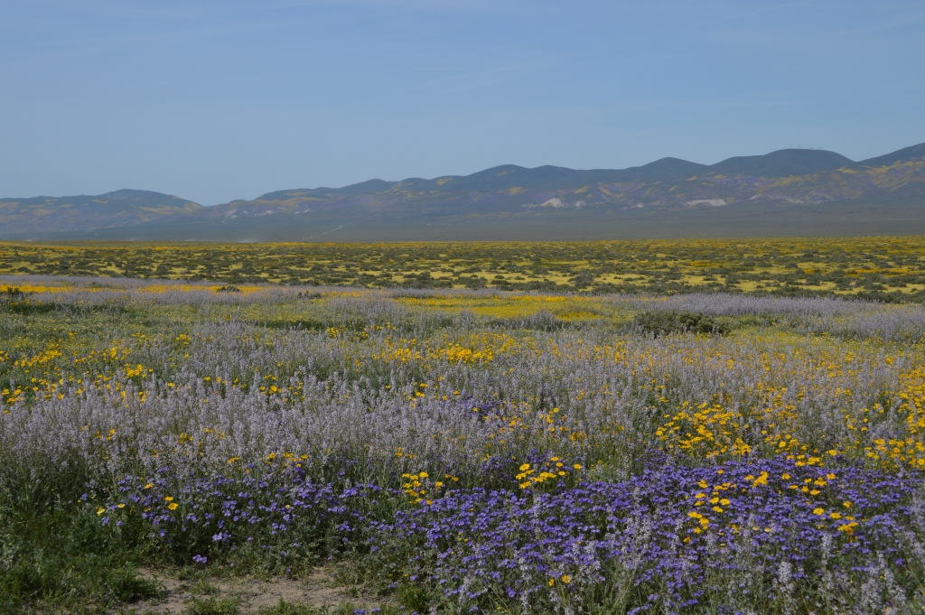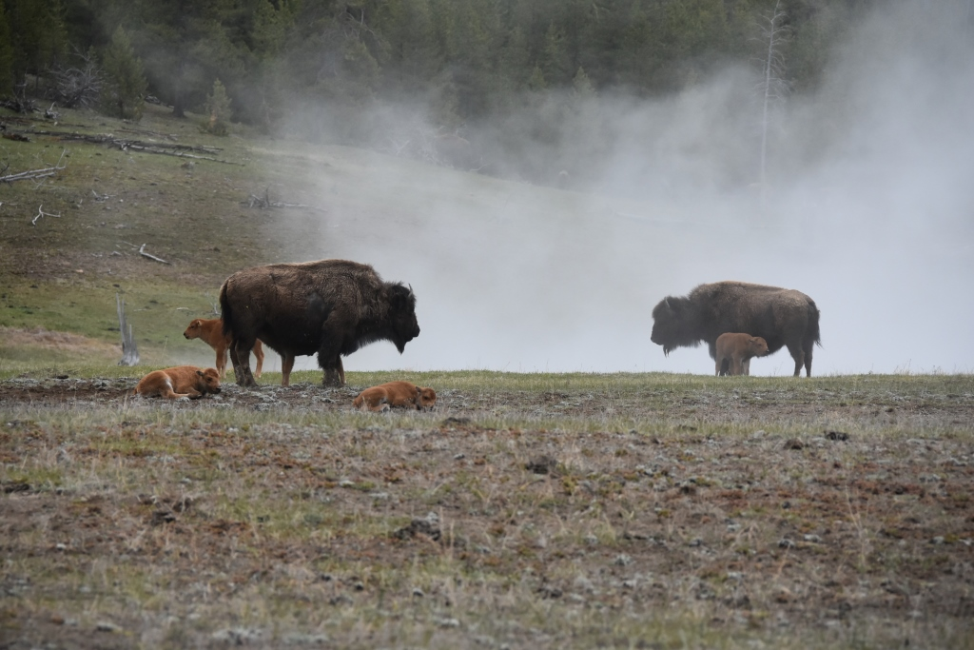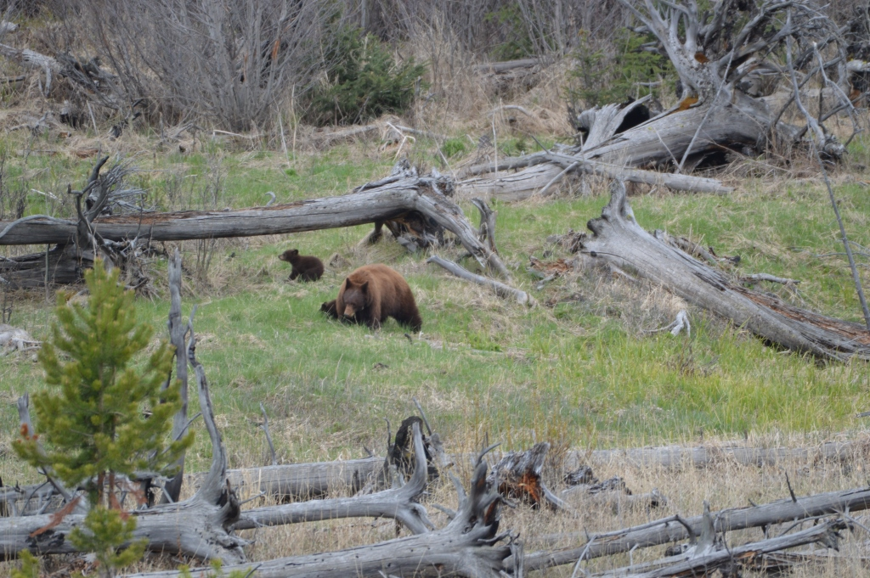
Carrizo Bison in Yellowstone bear and cubs

Apr: For the second year, the Carrizo plain has a spectacular display of wildflowers. It’s in the middle of nowhere, with nothing – no hotels, no restaurants, and, crucially, no gas stations, so you have to remember to fill up before you go. Ask me how I know this. Did I run out? No. Did I drive on Empty for many miles? Yes. Did I call AAA to have them deliver gas? No comment. (Just lucky, I gas. If I had to hazard a gas. Your gas is as good as mine.)

May: We go to Yellowstone with friends Alex and Roxanne. Better geothermals than Iceland! Moose (always amoosing) . black bears (bear with me, here), Grizzly bears. (Great furry things, thanks to the bear conditioner. I know. It’s unbearable) Wolves Q: What do you get when you cross a wolf with Fred Astaire? A: Dances With Wolves.) Wish we lived closer – it’s even better than Yosemite.

Jun: Neve graduates from small school; middle school starts in Aug. She’ll be married next time we look. Weekends are taken up with swimming for Lawson and Neve. (Dry humour only, please, or I’ll go off the deep end, in over my head).

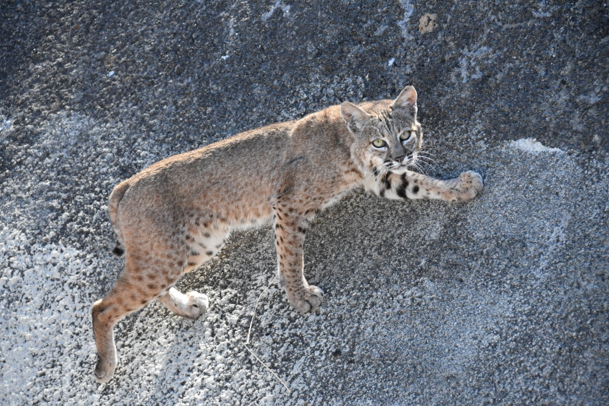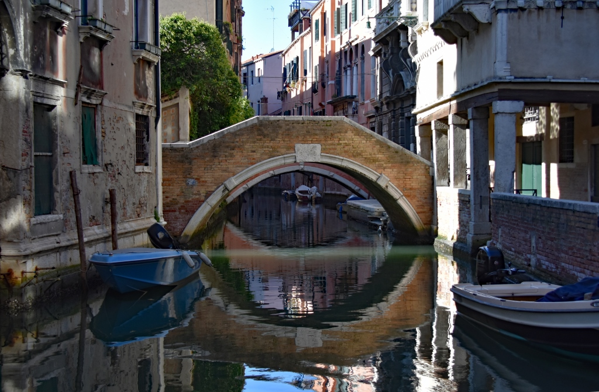

Jul: More swimming. I see a bobcat on the hill. We have a crop of home-grown potatoes (quite a-peeling, all of a spudden).

Aug: The Tardis goes into the shop for a refit. It had suffered from the rain, and hill subsidence, and neglect. To avoid it turning into a Tardisn’t, it got glued, painted, and regenerated. It’s now a ReTardis.

Sep: Off to Italy, with Alex, Roxanne, and Ann, British ‘Bloody Awful’ Airways strike notwithstanding. We were forced to leave home early, and spend more time there. Oh no. Milan, Cinque Terra, the Lakes and Mr Clooney’s pad (I just found out that George Clooney's wife has a twin brother named Juan who looks exactly like her. Some people say that once you've seen Juan, you've seen Amal), the splendid Verona, and Venice, then home (going, going , gondola).

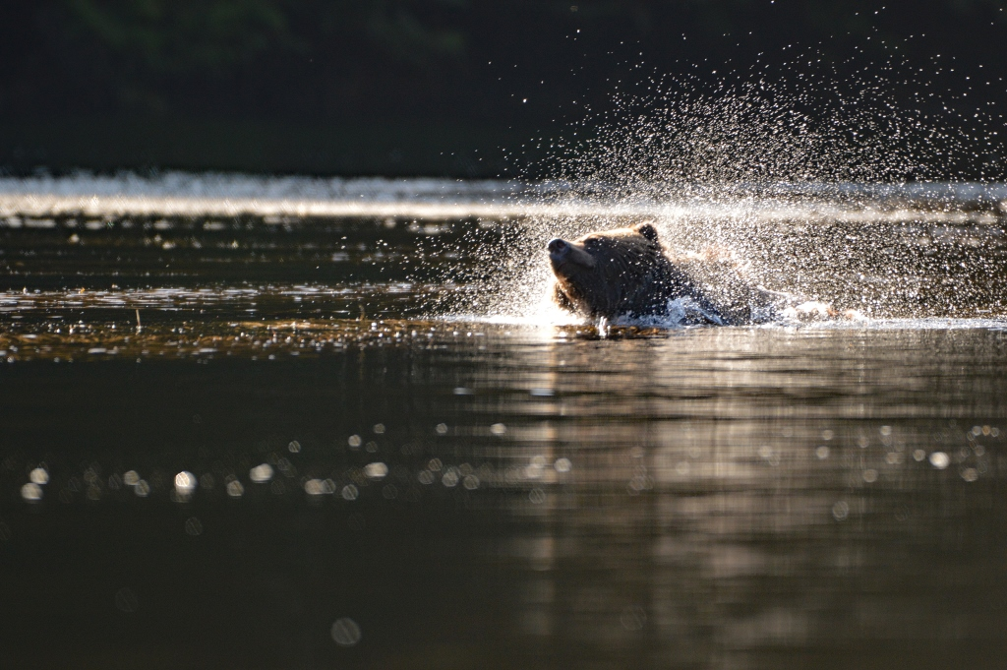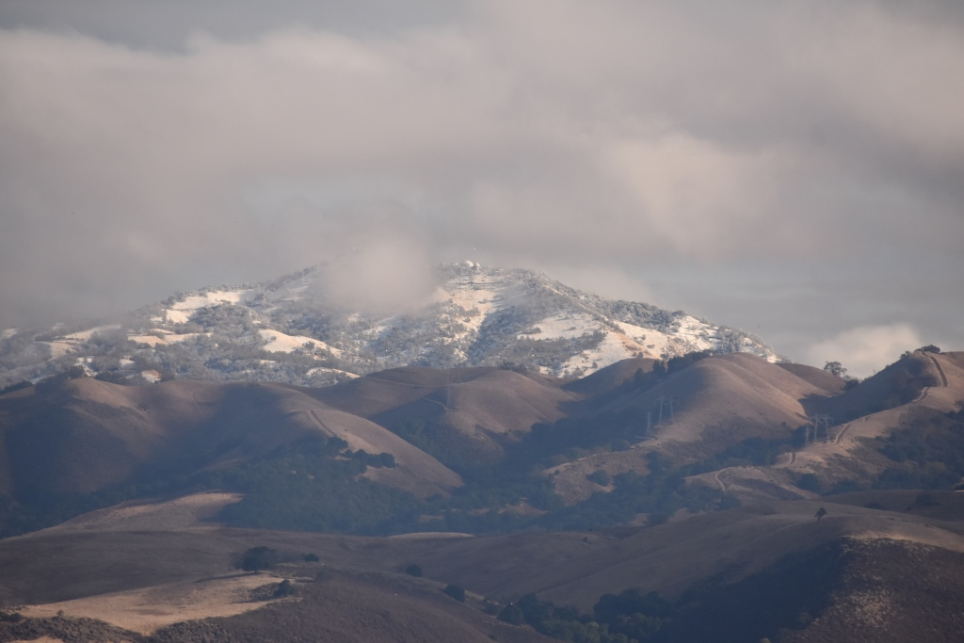
Arriving by Grumman Bear! Snow

Oct: Not a week back from Italy, and it was time to visit the grizzlies and bald eagles in BC, getting to the lodge by a 1942 Grumman Goose seaplane, because there are no roads. We saw and photographed 20 grizzlies (past the bear minimum), plus the one that walked a few feet behind us, giving the guides paws. (What do you call a bear covered in a bunch of crows?A grizzly murder). On our return we go to Lodi to see the sandhill cranes at sunset. I am a turkey for Halloween. (If we were still in Yellowstone, we’d see lots of wolves at howloween).

Nov: The earliest snow at the observatory, at Thanksgiving. Good thing this climate change thing is a Chinese Hoax. (Say it ain’t snow. This is snow laughing matter.)

Dec: Yule be sorry about this set! Christmas has me feeling extra Santa-mental. Did you hear about the dyslexic Satanist? He sold his soul to Santa. Santa is an elf-made man. He has high elf-esteem. Believe in your elf. Have your elf a merry little Christmas. All I want for Christmas is ewe. (This joke for the Scottish, Irish, and NZ audience).

2020 Wishing you all a Merry Impeachmas. Come November, our fate will be determined – will the mentally disturbed narcissistic sociopath dictator be re-elected? . There may not be a letter next year.

The following section is for 10 year olds and grandpas of a Certain Age.

The best bear jokes.

- A Russian scientist and a Czechoslovakian scientist had spent their whole lives studying the majestic grizzly bear. Each year they petitioned their respective governments to allow them to go to Yellowstone to study these wondrous beasts.
Finally, their request was granted and they immediately flew to New York and then on west to Yellowstone. They reported to the local ranger station and were told that it was the grizzly mating season and it was much too dangerous to go out and study the animals.
They pleaded that this was their only chance. Finally the ranger relented. The Russian and the Czech were given cell phones and told to report in each and every day.
For several days they called in, and then nothing was heard from the two scientists. The rangers mounted a search party and found the scientists' camp completely ravaged. No sign of the missing men.
They then followed the trail of a male and a female bear. They found the female and decided they must kill the animal to find out if she had eaten the scientists because they feared an international incident.
They killed the female and cut open the bear's stomach... only to find the remains of the Russian.
One ranger turned to the other and said, "You know what this means, don't you?"
"Of course," the other ranger nodded. "The Czech is in the male."

- A grizzly bear walks into a bar.
He leans on the bar and says "Barkeep, I'll have a...
...
...
martini, please."
And the bartender says, "why the big paws?"

- A Yellowstone Park Ranger tells everyone to wear bells around their neck and carry pepper spray to ward off a bear attack. The bells alert the bears to your presence and the spray is a last ditch, ten feet, "hail Mary", when all else fails. He tells the hikers that there are two kinds of bears in the area: Grizzlies and Black bears. He then tells them that they need to recognize the bear's scat so they can tell the two species apart. He says that black bears are much less likely to attack, so when they see black bear scat, they may continue. But if they encounter grizzly scat, they should give the area a wide berth.
A tourist asks how to tell the difference. The ranger replies," Easy, black bears are grazers, more than fish eaters. The black bear scat is usually full of blackberry seeds and acorns and other plant life and it smells like almonds. Grizzly scat is larger and it is full of bells and smells like pepper spray.

The best Christmas puns

- “Why did they ask the turkey to join the band? He had the drum sticks.”
- “Why did the elf push his bed into the fireplace? He wanted to sleep like a log.”
- “What do snowmen eat for breakfast? Snowflakes.”
- “The turkey wasn’t hungry at Christmas because he was already stuffed.”
- “Children who don’t learn to tie their shoes properly are bound to wind up on the knotty list.”
- “What do you call people who are afraid of Santa Claus? Claustrophobic.”
- “Why does Santa Claus go down the chimney on Christmas Eve? Because it soots him.”
- “Christmas has me feeling extra Santa-mental.”
- “How do the elves clean Santa’s sleigh on the day after Christmas? They use Santa-tizer!”
- “Santa’s beard is so long because he’s bad at shaving. Why do you think they call him Saint Nick?”
- “Remember not to leave a fire burning in your fireplace this Christmas Eve, or else you might wake up to a Crisp Kringle.”
- “What would you get if you ate the Christmas decorations? Tinselitis.”
- “The North Pole doesn’t import Chinese goods because it’s Elf Sufficient.”
- “What do you call an elf that runs away from Santa’s Workshop? A rebel without a Claus.”
- “Elves are always defending the shape of their ears. They make some good points.”
- “Did you hear the forecast for Christmas Eve? They’re calling for rain, dear!”

