2020 – A plague on all our houses

The 32nd edition. 1¹ + 2² + 3³ for the arithmetically inclined

“What sort of god makes rats and plagues and dwarfs?” – George RR Martin
The Xmas letter is going to disappear. One day — it’s like a miracle — it will disappear. –DJT
We have the Xmas letter totally under control. --DJT
You know, a lot of people think the Xmas letter goes away in April with the heat — as the heat comes in. Typically, that will go away in April. –-DJT

The Xmas letter, you will note, doesn’t go away.

But this year, since you need uplifting sentiments and amusement, it doesn’t mention the C word. Unlike every other end-of-year thing on the planet.

Just kidding. Of course it does.

Now you might think that the Xmas letter this year would consist of Jan, Feb, then << blank space for many pages>>. And you should be right. But Xmas letter writers are a stalwart bunch, so padding will be employed.

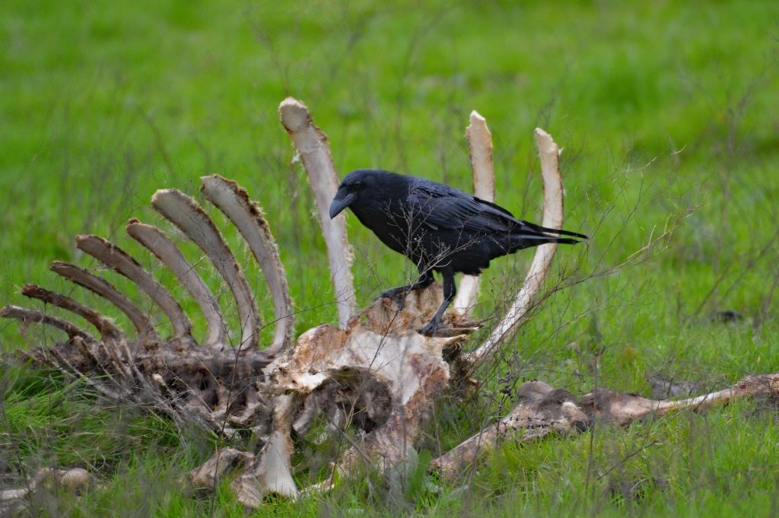

Jan: The year starts normally enough, with the traditional trip to Santa Cruz on the 1st. We have a touch of snow on the mountains. A cow dies on the hill. Ravens and vultures arrive. (This should have been the second clue. The first was the continuing onslaught of DJT’s deranged tweets). Somebody eats a bat. I have a haircut.

Why did the chicken cross the road? Because the chicken behind it didn’t know how to socially distance properly.

Feb: We go to Point Lobos. We go to Lodi to see the Sandhill Cranes (achieved) at sunset (failed). I do my first mocking post of Trumpf at the Covid Task Force – a job he gives to Android Pence, until he discovers there is publicity involved.

Which Christmas film was 30 years ahead of its time? Home Alone.

Mar. My post announcing that we were self–quarantining (the correct terminology was stay-at-home) is on Mar 13, six days before CA makes doing so mandatory. It hails on Mar 17. (This was the third clue.) On Mar 24, I start my daily FB “on this date” series of pictures. This will continue until something somehow declares it all to be over. I should be having a haircut around now, but I decide, given the circumstances, to become Cool, which can only be done if you have a manly man-bun. We stock up on TP, because it’s the only way to beat panic buying.

..And better than the alternative, using lettuce leaves. Just the tip of the iceberg, tomorrow romaines to be seen.

Apr: Outings now consist of walks along the canal. We hear gunshots (fourth clue) and call the cops. It turns out the rich guy on the top of the hill was shooting turkeys illegally. After 7 cop cars descend on the Court, I prove guilt with a photo of the clown taken with the big lens. Fish&Game give him a ticket and confiscate his gun.

I never thought the comment “I wouldn’t touch them with a six-foot pole” becomes official Government policy.

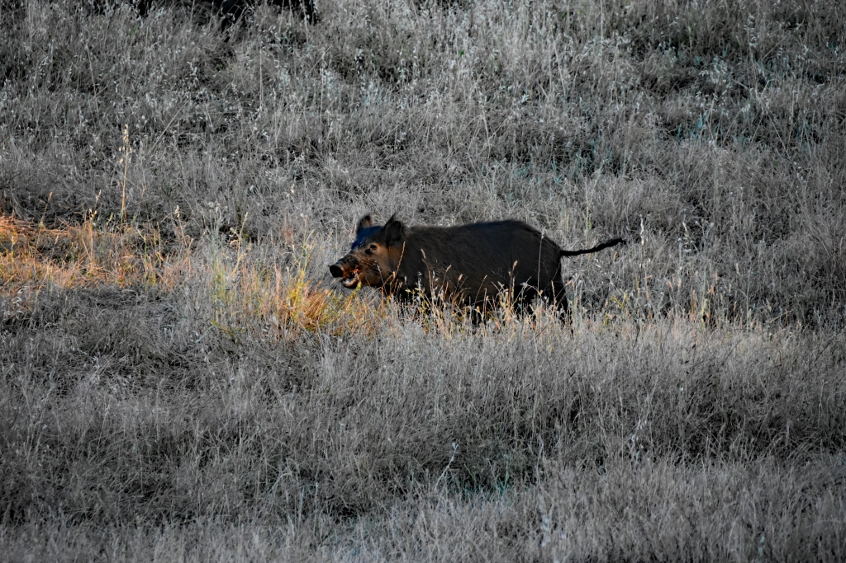

May. We have wood rats. Two, although one soon disappears. Two hardly counts as a plague, but you never know how fast they can reproduce. We have pigs. It’s unclear whether pigs are part of The Great Plagues. We have a gopher snake (pshaw!) and a rattlesnake. Hmm.

You know what they’re saying about 2020. It went viral faster than anyone thought it would.

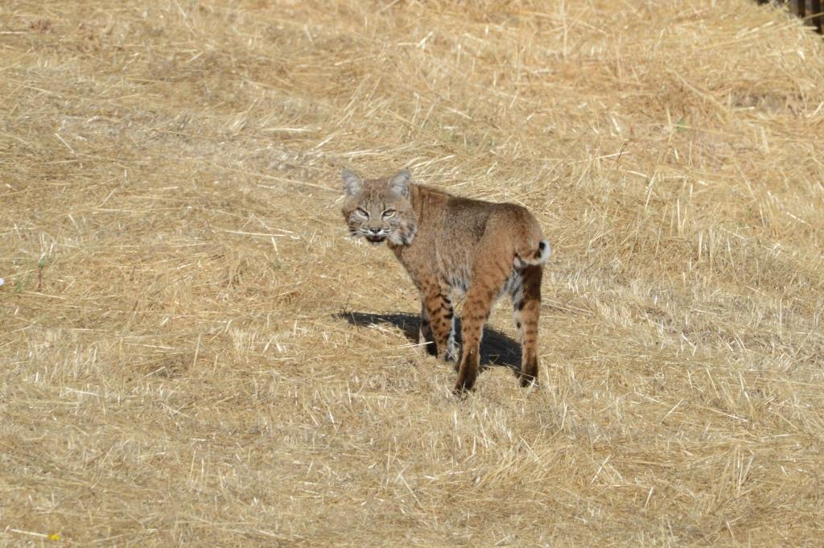

Jun: We have a racer snake, rabbits, another gopher snake, and a bobcat. As plagues go, this is poor, although my money’s on the rabbits.

I’d tell you a coronavirus joke now, but you’ll have to wait two weeks to see if you got it.

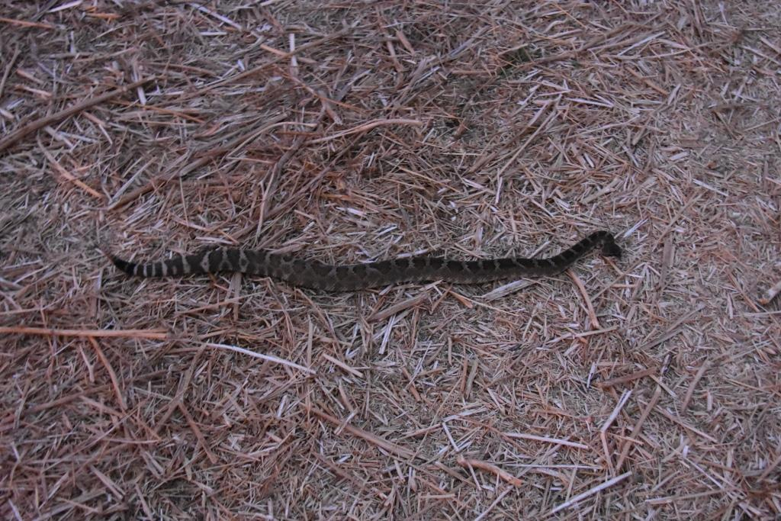 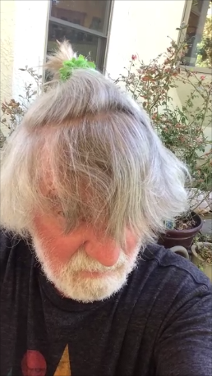Man Bun.
Jul: We have a huge party on Jul4 with all the neighbours. (No, we don’t). I give up my manly Man Bun idea; after 6 months of no haircut, I get a bootleg one.

Did you hear the joke about Covid? Never mind, I don’t want to spread it around.

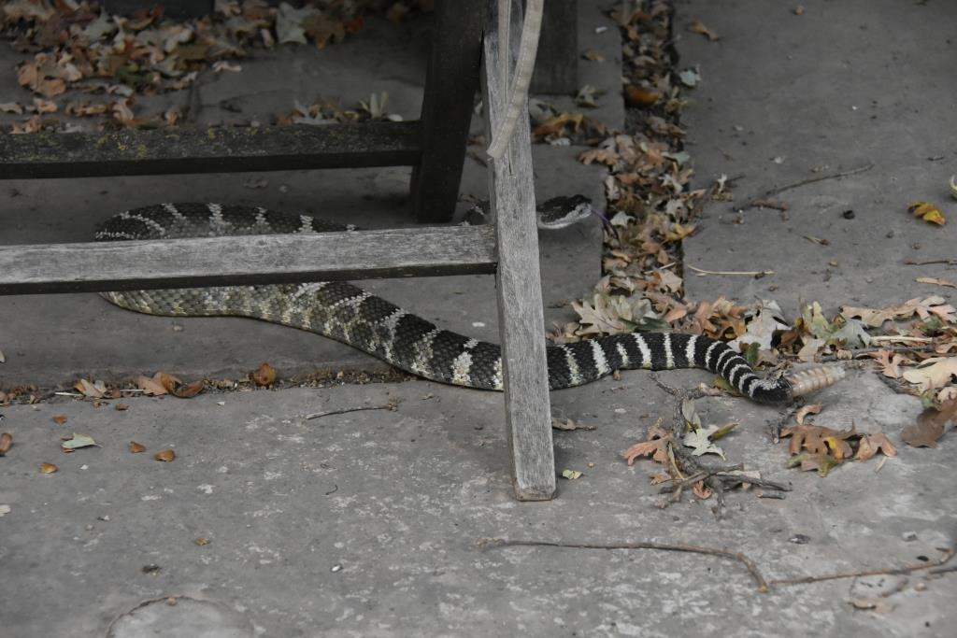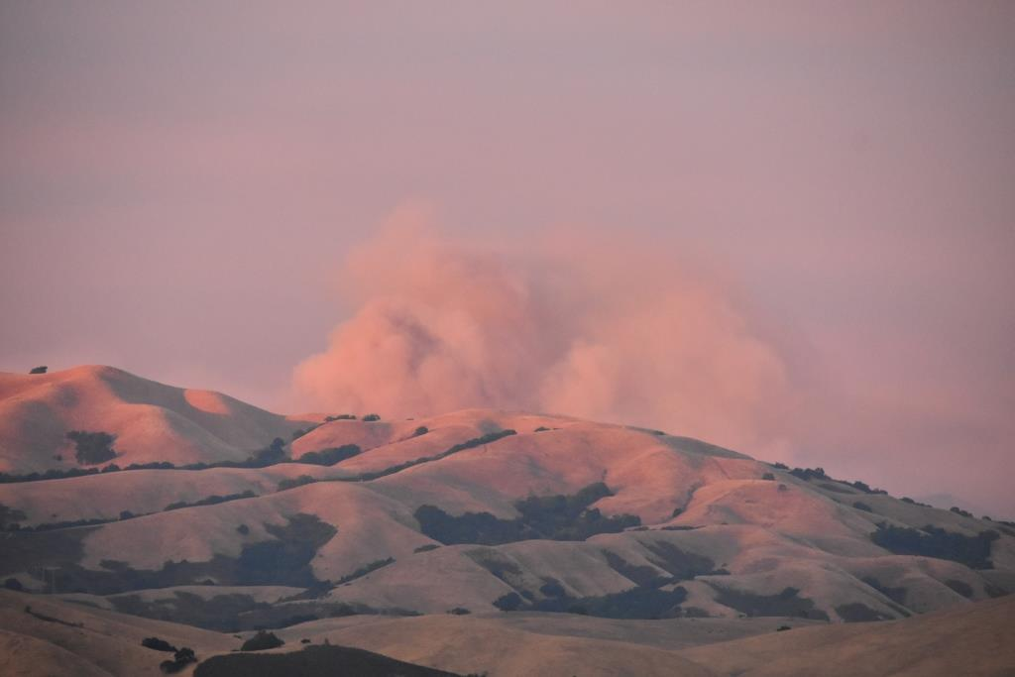

Aug: to celebrate Iain’s and Cheryl’s Big Birthdays, we spend a day driving socially distanced cars around Pebble Beach: a Cobra (Cheryl), a Challenger (Iain), and a Mustang convertible (us). As was (and is) the way of Chryslers, the Charger broke down at the end. Still, good fun. A Bald Eagle took up residence at the local park. We have a rattlesnake. The CA fires start – not near us physically, but the smoke fills the valley for a highly unpleasant month. Now we have to stay indoors. Two more rattlesnakes arrive (at surprising speed). Definitely a plague.

The World Health Organization announced that dogs cannot contract Covid. Dogs previously held in quarantine can now be released. To be clear, WHO let the dogs out.

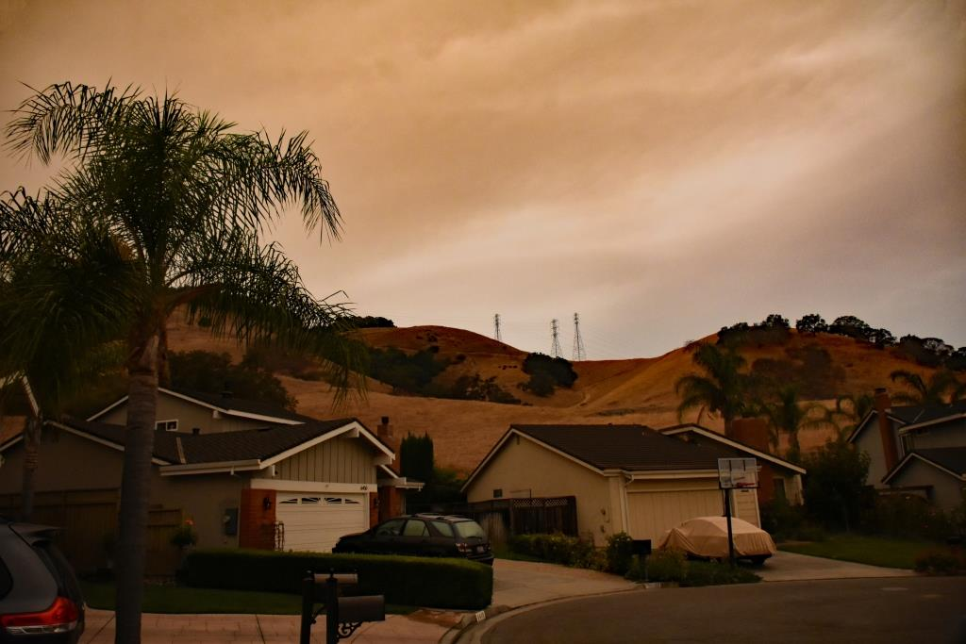 The court at midday. Street lights on.

Sep. Fires continue. We go to Point Lobos, since it is again open and, importantly, its bathrooms are open.

What’s the difference between Covid and Romeo and Juliet? One’s the coronavirus and the other is a Verona crisis.

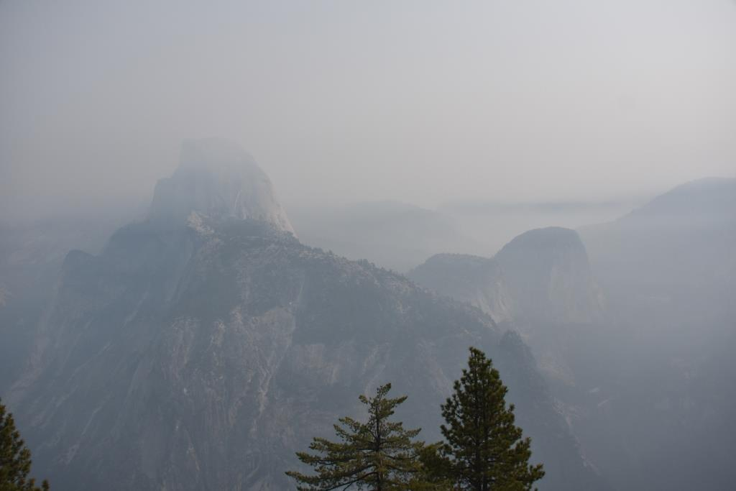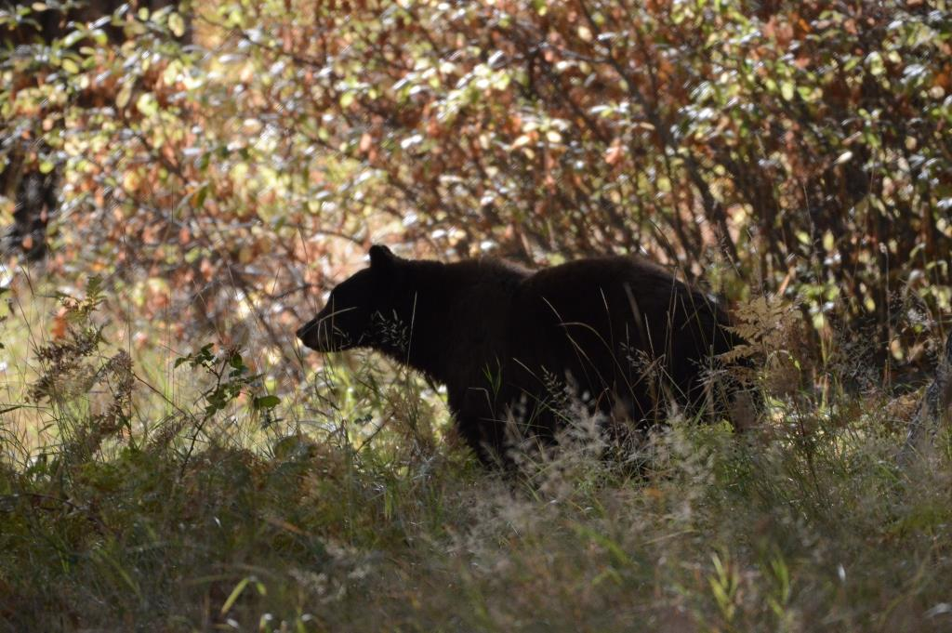

Oct: We go to the Ahwanhee in Yosemite. For the first time in 2020, we sleep in a bed which is not our own. We stay in a Cottage (safer than the rather enclosed hotel building). We have takeout food from the Ahwanhee dining room. You can, if you wish, eat in the magnificent Ahwanhee dining room, with your cardboard box and plastic knife and fork and no waiters.. but we don’t. (Even so, there is still a dress code. It seems not to be enforced). Yosemite is full of smoke from the latest fire, and Half Dome is bearly visible. (That’s a clever misuse of English since we did see, count ‘em, two bears in the valley. )

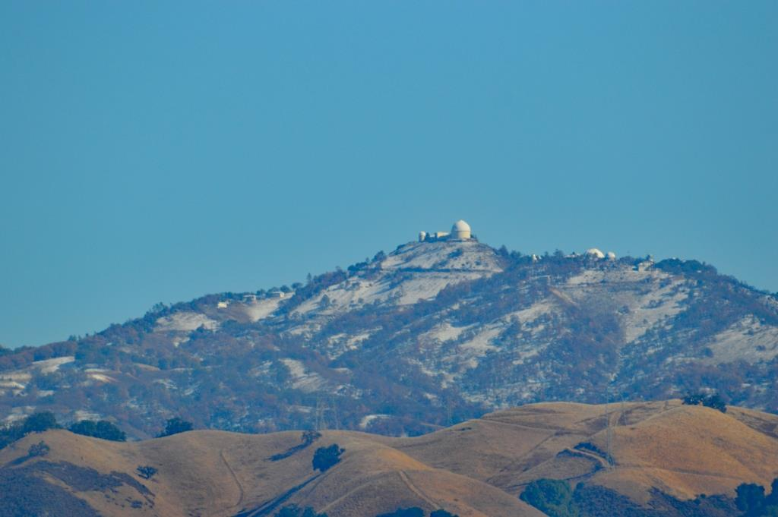

Nov: A day trip to Lodi to see the cranes at sunset. (Successful). We had takeout pizza with friends with a picnic table set up in a local park, which amused the locals. It snows on the Lick – earliest snow ever.

Quarantine has turned us into dogs. We roam the house all day looking for food. We are told "no" if we get too close to strangers. And we get really excited about car rides.
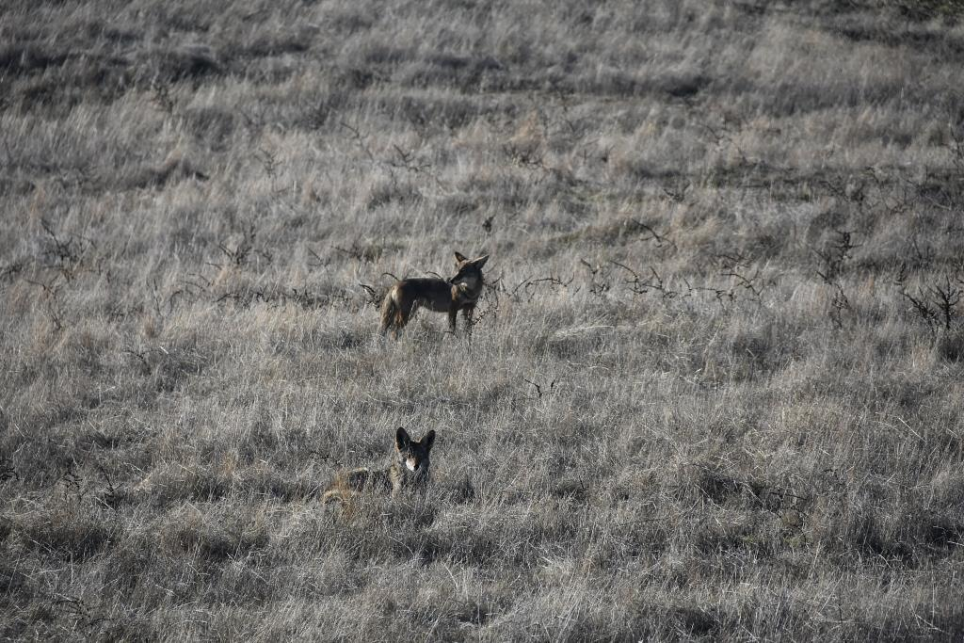

Dec: Multiple coyotes on the hill. Must count as a plague.

Why are Santa’s reindeer allowed to travel on Christmas Eve? They have herd immunity.

So there we have it. A plague of Plagues. A stinker of a year.

2021 – the forecast

No DJT. Even if (as we all hope) he’s dragged out by his ankles. (Now THAT would help his beloved Ratings).

Vaccine! We’ll maybe keep the other plagues, but the C one will be over.

And rebuilding, after a lost year. I feel for the kids; a year is such a large percentage of their life to be lost. I feel for old people; it’s such a large percentage of what life they have left. I feel for all those who lost their jobs, even temporarily.

There have been three, or ten, or twenty recorded plagues in history. Smallpox, measles, bubonic plague, cholera (many times), flu (many variants), AIDS, .. the list is long. Covid is bad. But .. compared to most of these others: we understand it. We know how to minimize risk (although many willfully and stupidly ignore that). We have a vaccine for it. And no matter how much you hate Zoom meetings, we could still work and communicate during it. Imagine, for a moment, life during the 6 years(!) of the Black Death in the 1300s.

Hang in there. Pretty soon 2020 will be just a bad memory.

Also the number of completed, numbered piano sonatas by Ludwig van Beethoven; the number of teeth in an adult human, including wisdom teeth; a Leyland number since 2⁴ + 4² = 32; Leyland made buses. Thus endeth the educational section of the program.
Of course he meant squirrels instead of rats, and I don’t know why he has this thing about dwarves.
Home Alone 2 had a cameo by one DJT, which is a pretty good reason not to watch it. CBC cut him when they show it. Canadians are such civilised people.
Like waiters – remember them? - or unemployed actors, also known as waiters.

