Xmas 2023
The 35th edition of the Xmas letter, which would never lie to you. Declared illegal in Colorado.
This year’s theme is Dictators. (I wonder why)
Most of them die - some from the enraged population (Mussolini, Ceausescu, Saddam, Gadhafi), some by suicide (Hitler), but mostly from natural causes (Stalin, Mao, Franco, Papa Doc, Amin, Lenin, Napoleon, Chavez, Cromwell). They seldom give up power voluntarily – but some do (Cincinnatus, Indira Gandhi, Pinochet, Ortega, Nyerere). None has been Dictator-for-just-a-day.
Identify the dictator from the quote. If you win, you get to be Benevolent Dictator, once there’s a vacancy.
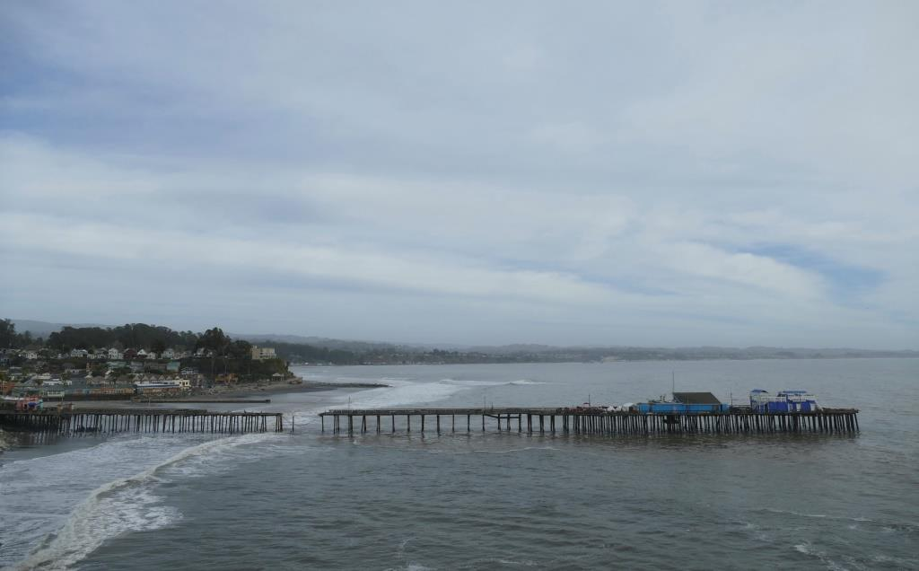
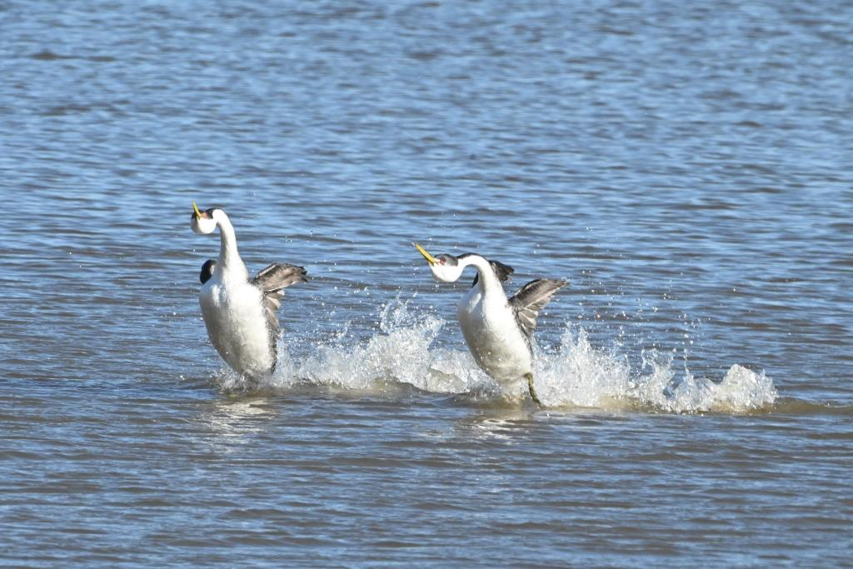

Jan: I dig out the raised beds, which have been filled by tree roots. Again. Big storms attack Santa Cruz and Capitola – a very wet winter has made the Great California Drought disappear, at least temporarily.
I always win, I'm cursed to win.
Feb: I finally get a pic of grebes rushing. And then of ladybugs overwintering, with Ann (she overwinters too, from Canada, but that’s a different phenomenon). Cranes at Merced NWR. We’re just natural naturalists. If we were naked, we could be, naturally, natural naturist naturalists, but you can remove that image from your brains now. If only.
I am not a dictator, and I do not think I will become one.

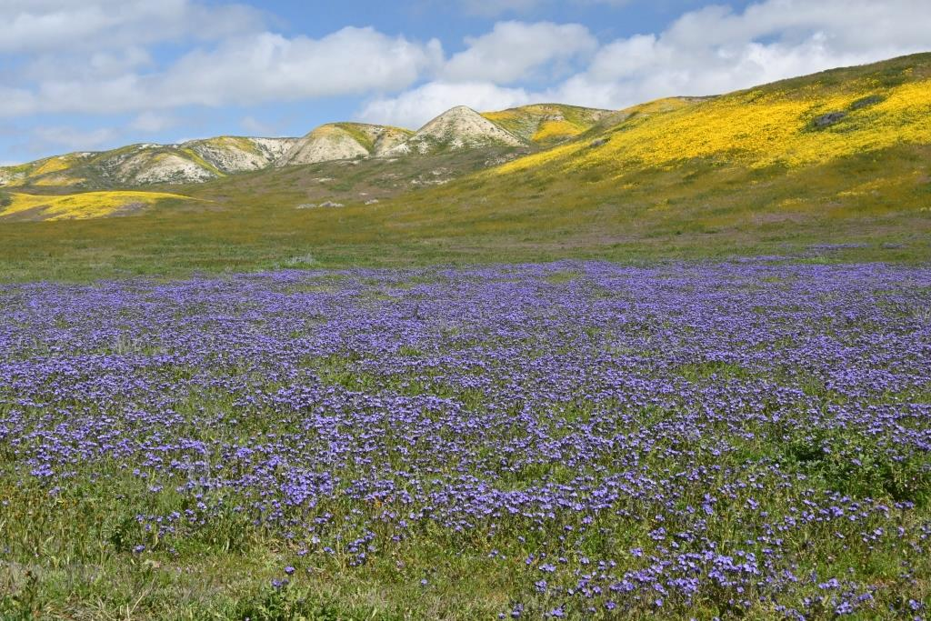
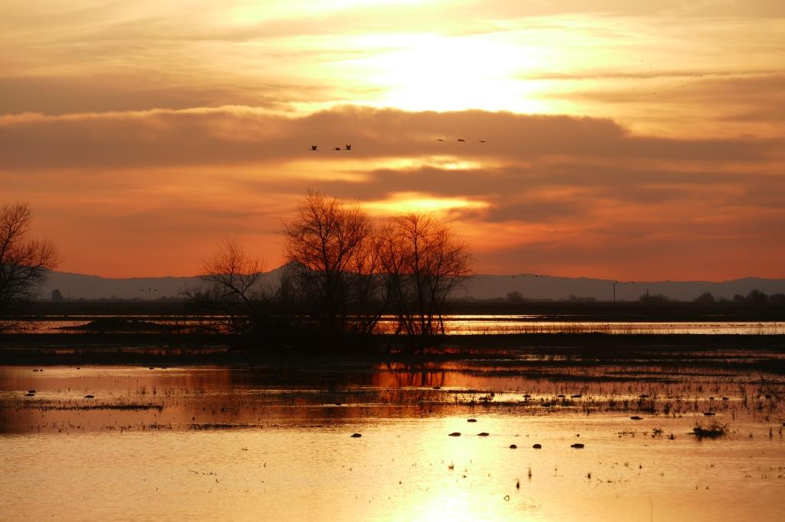

Mar: We go to the Carrizo Plain to see the superbloom of the wildflowers (this was a very wet winter, which is necessary for superblooms).

I’m not a dictator; it’s just that I have a grumpy face.

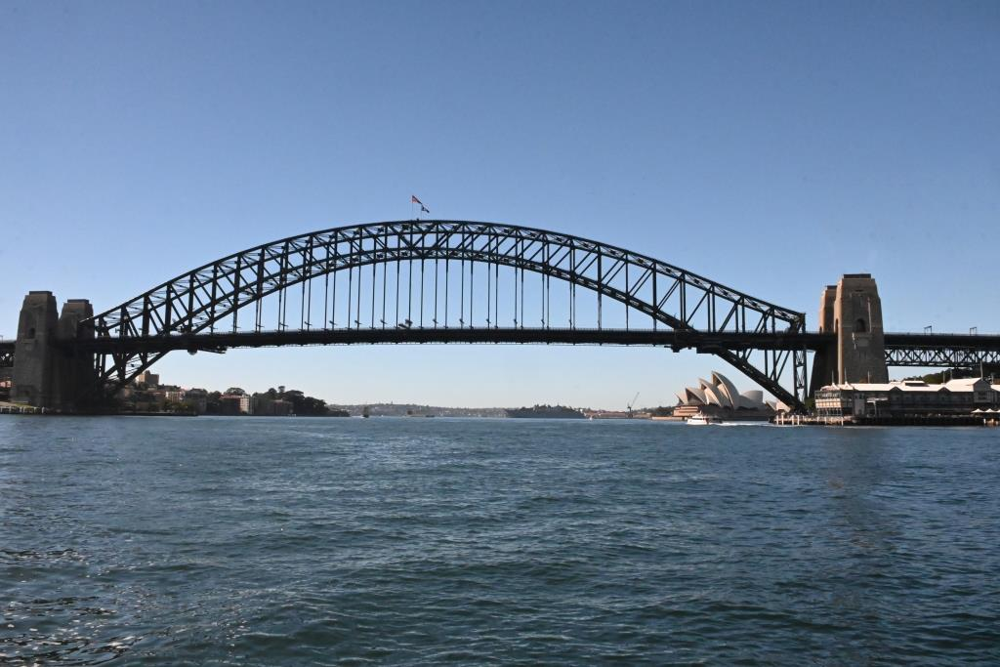
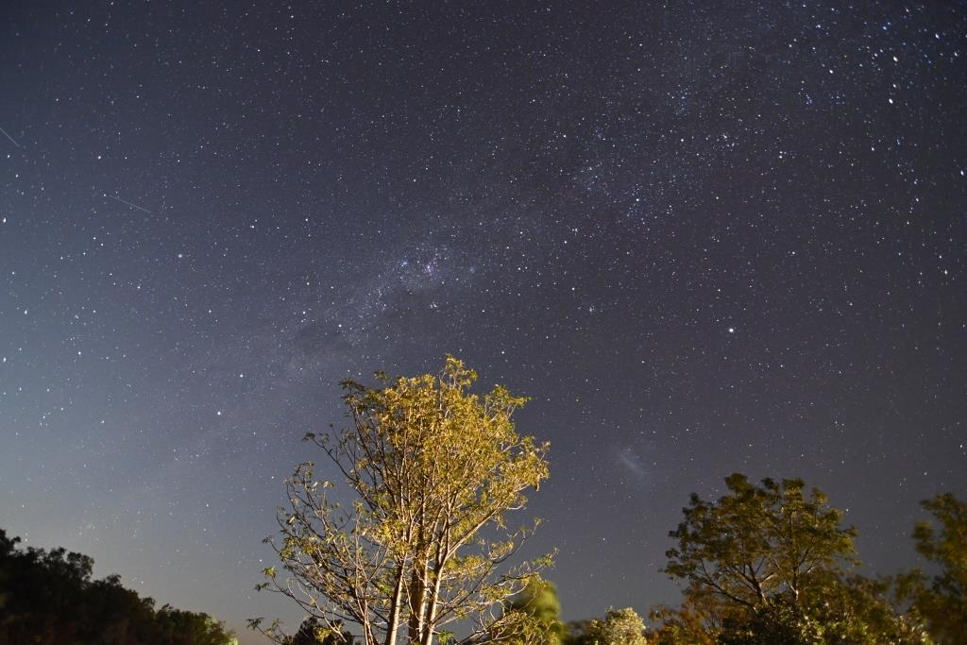

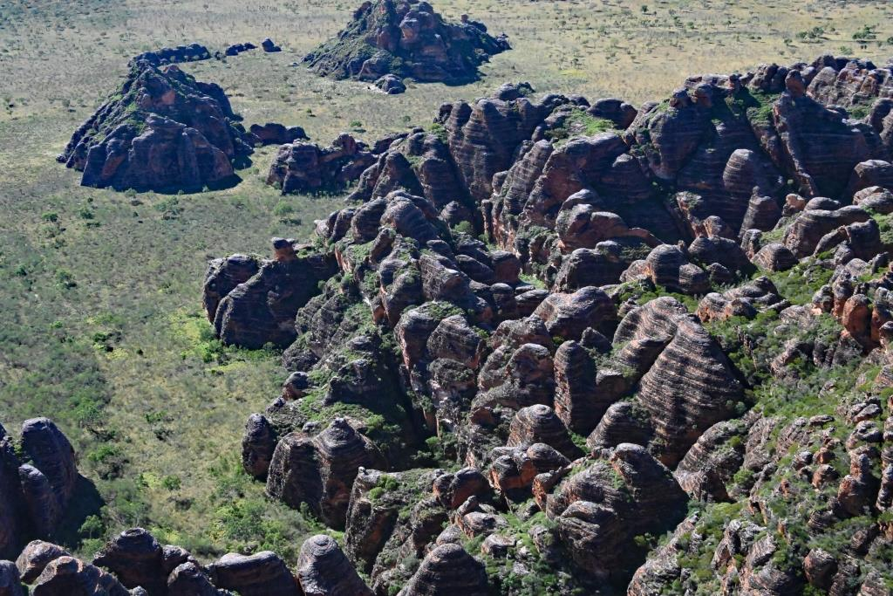
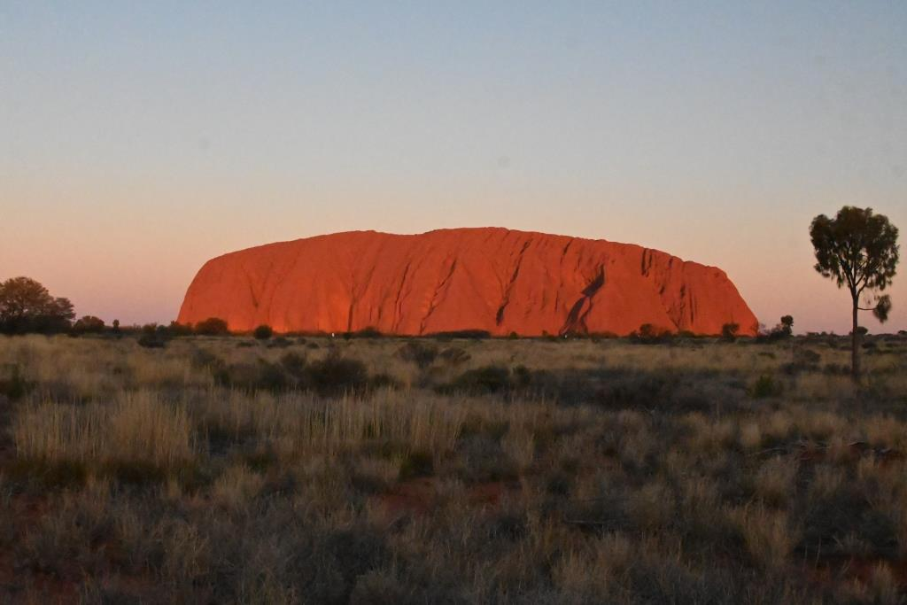

Apr: We are off to the land of Oz, the bit nobody ever goes to, which the Ozzies call the Top End (it’s really the top left part, but being as how they live upside down, you can understand their confusion). Broome to Darwin, via the famous BungleBungles. We survive, although I am blamed for allowing congregations (that’s the correct word) of frogs to come out of the toilet in the middle of the night to stare at us. On the way back we visit Uluru (again – it’s still great), and Melbourne to see nephew Neil and family, who gave us a tour in their fleet of Teslae.
The truth is that men are tired of liberty.

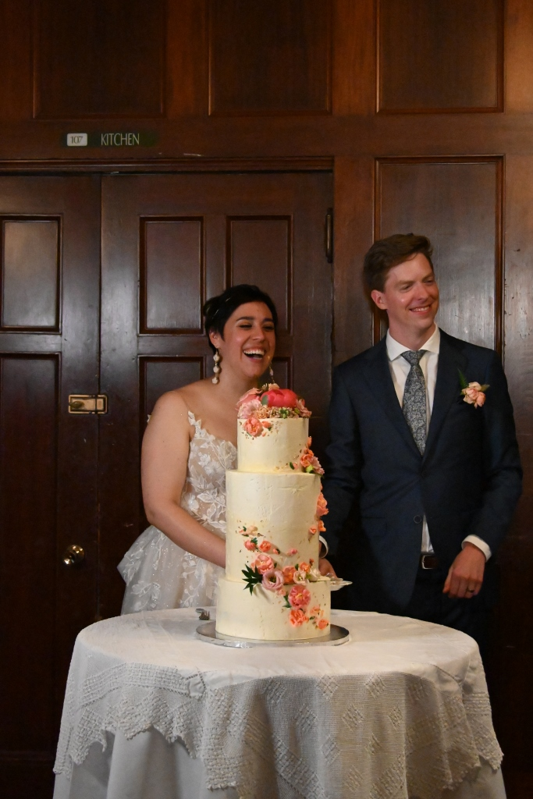

May: We get back just in time to go to the wedding of Natasha and Quinn in Vancouver, eh. She is Rowena’s cousin’s daughter. Also Butchart Gardens, and the Empress Hotel, which was more successful than our first visit in 1976 when we were penniless. We were not kicked out, but nor were we served. BC is beautiful, and also handy should there be a sudden infestation of orange Dictators.
If you wish to be a success in the world, promise everything, deliver nothing.

Jun: Kid swimming is back. We go to Point Lobos. Capitola is back, except for the pier.
Make the lie big, make it simple, keep saying it, and eventually they will believe it

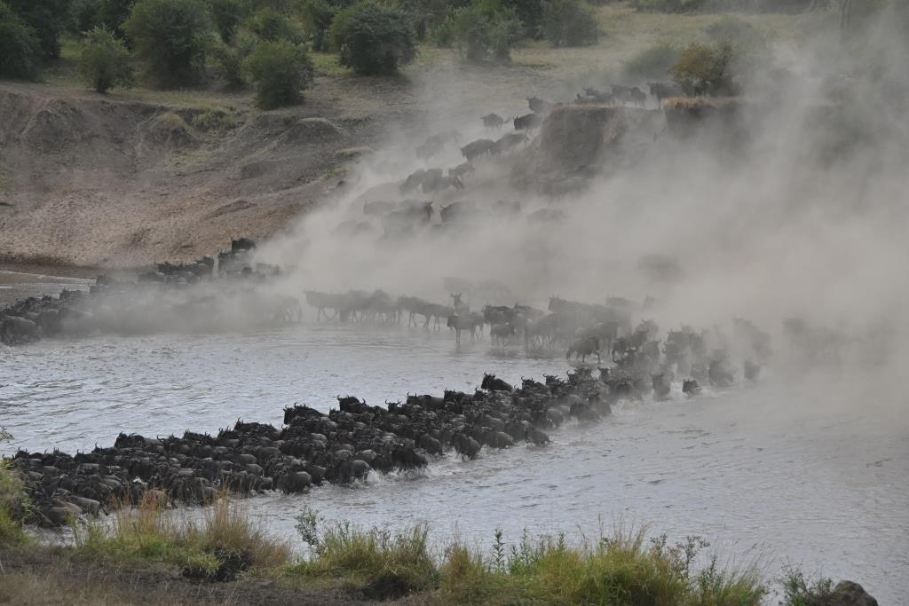
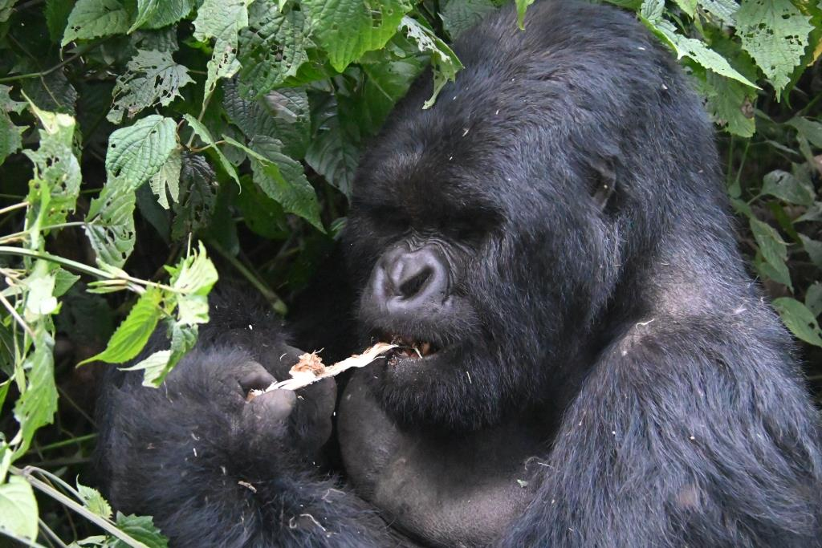

Jul: Our much delayed trip to Africa actually occurs, after 3 years of delays, caused by some global event. Tanzania to see the Great Migration, and Rwanda to see the gorillas, with Tim&Fiona and kids. We go via Amsterdam (Fiona added a world tour of Europe and Asia as well) and return via London, briefly. Did we see wildebeests? Yes. Was I touched by a gorilla? Yes. Was anyone eaten by lions? No. Do I recommend it? Yesyesyes.
The masses are more likely to believe a big lie than a little one.
Aug: Life returns to normal. Car show.
One has to be insincere and promise something which you cannot fulfill. So you either have to be a fool who does not understand what you are promising, or deliberately be lying.

Sep: We do nothing. Perhaps we are suffering from travel overload. Perhaps (and I prefer this answer) space aliens took us away for naughty experiments, and erased our memory (and my camera’s SD card).
XXX, the dictator, ruled the nation with an iron fist. Under the new emblem of the double cross, liberty was banished, free speech was suppressed and only the voice of XXX was heard.
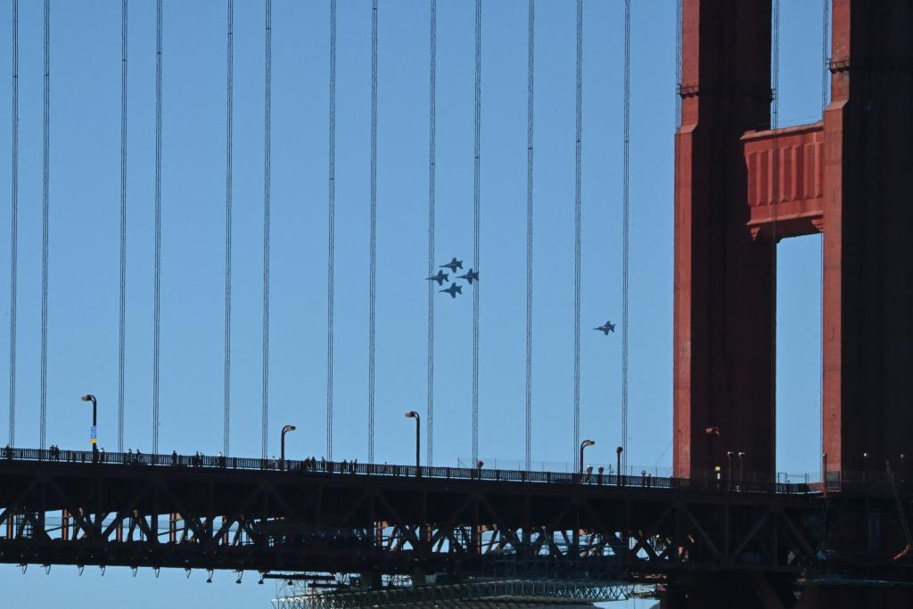
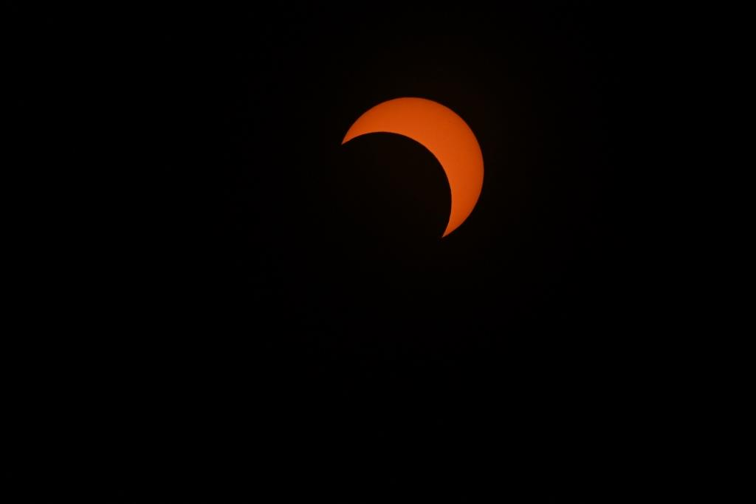

Oct: The aliens free us. I get pictures of Blue Angels over the Golden Gate, better than last year where we could see neither the bridge nor the planes, because of the SF Fog, which is called Karl. (This is true). Next year we will stand somewhere even better. A (partial) solar eclipse.
I wanted to be a painter.

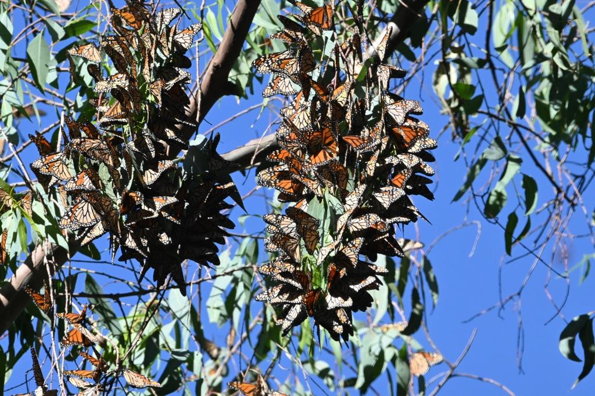
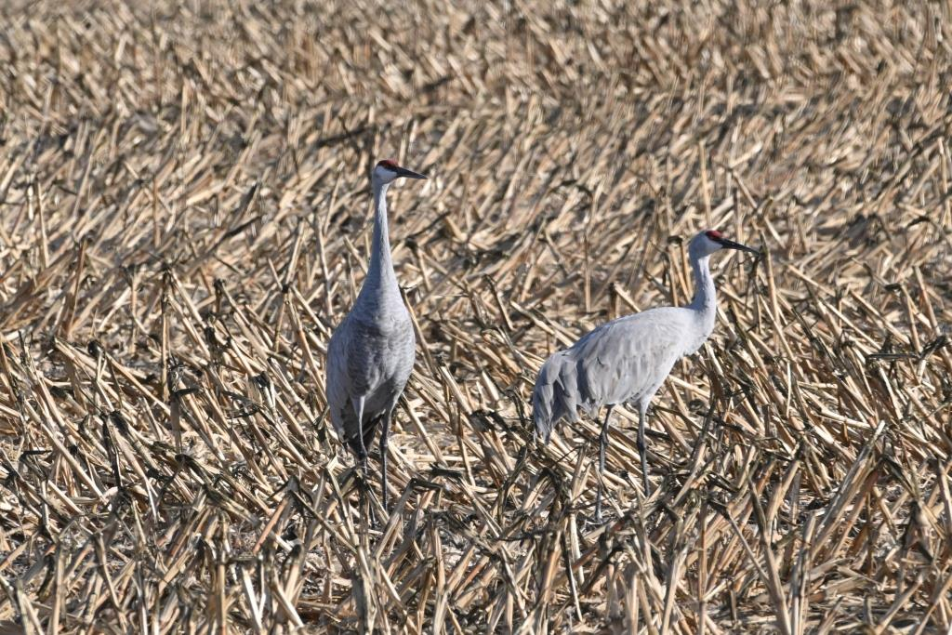
5

Nov: Pumpkins. (I missed them last year due to a certain medical condition). Cranes. Monarch butterflies. Full moons. I bet there was even better stuff in September. Damn aliens.

I don't care if they respect me so long as they fear me.

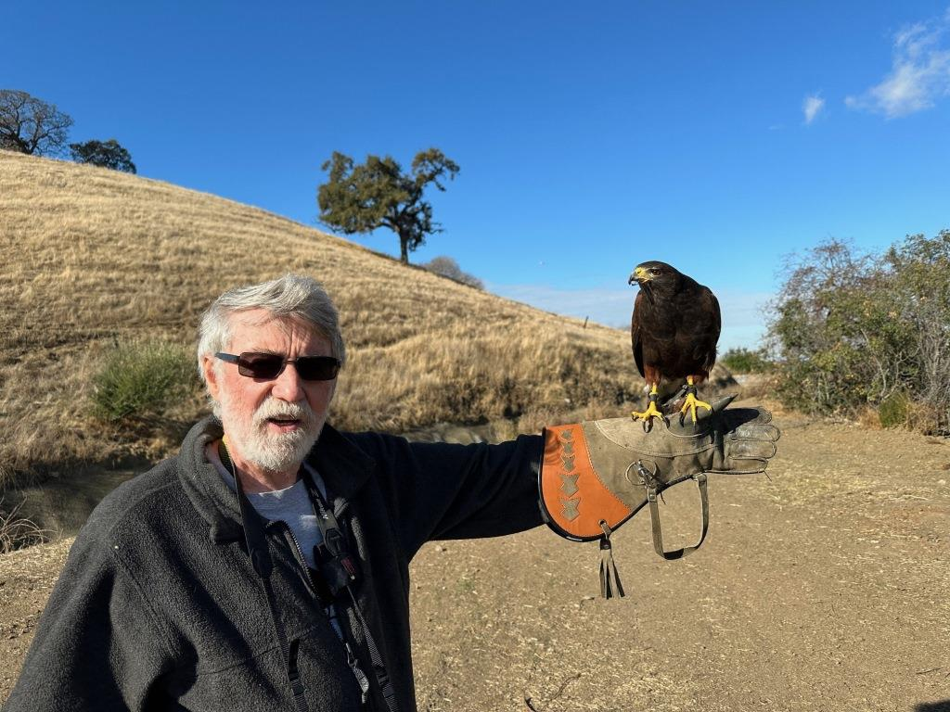

Dec: I become a falconer. Everyone needs a hobby. We are off to San Diego to have Xmas with Iain and Cheryl.
To be honest, this country needs a dictator.

May you survive 2024. It might not be easy.

Like the immortal Jimmy Carter
Although Cincinnatus came close: 16 days. Maybe; documentation is sparse.
Berlusconi. No, not the Orange Voldemort.
Fidel
Pinochet
Mussolini
Napoleon
Hitler. Also A lie told often enough becomes the truth." - Vladimir Lenin
Hitler
Putin
Charlie Chaplin, about the Great Dictator
Chavez. Lose points if you said Hitler.
Caligula
My prediction: Mango Man will say this, before Nov 2024. Probably tomorrow.

